# **Table of Contents**

**Table of Contents 1**

**S3 bucket 2**

***Class Room Discussion*** *2*

***Diagram*** *2*

***High-level steps*** *3*

***Rules and Policies*** *3*

***Screenshots for S3 Bucket Creation*** *4*

***Screenshots for Enabling Versioning on an Existing Bucket*** *6*

***Screenshots for checking the versioning*** *8*

***Screenshots for Recovering a Deleted File*** *12*

***Screenshot for to Set Up Replication in S3*** *16*

***Screenshot for Providing Public Access to a File in S3*** *25*

***Screenshot for Changing the Storage class of objects*** *32*

***S3 Lifecycle Policies to Change Storage Classes*** *35*

***Screenshot for Static Webhosting creation*** *38*

# S3 bucket

### **Class Room Discussion**

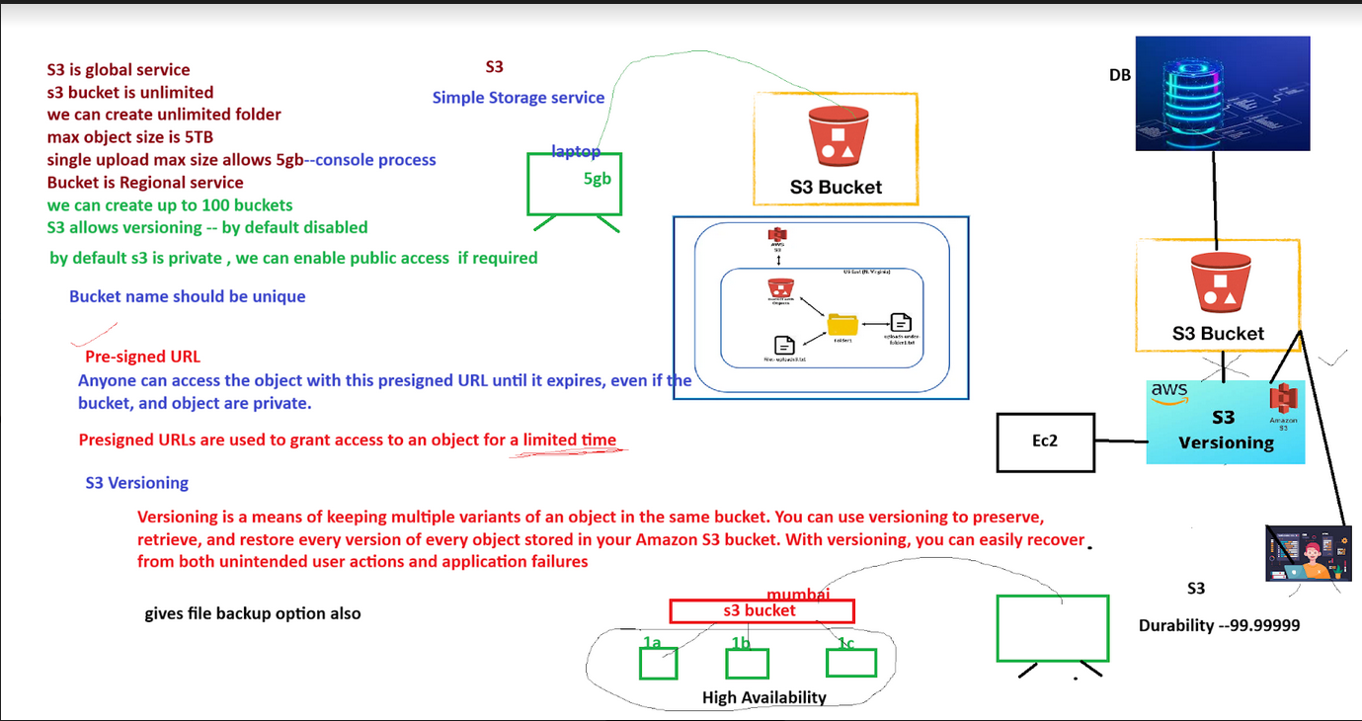

### **Diagram**

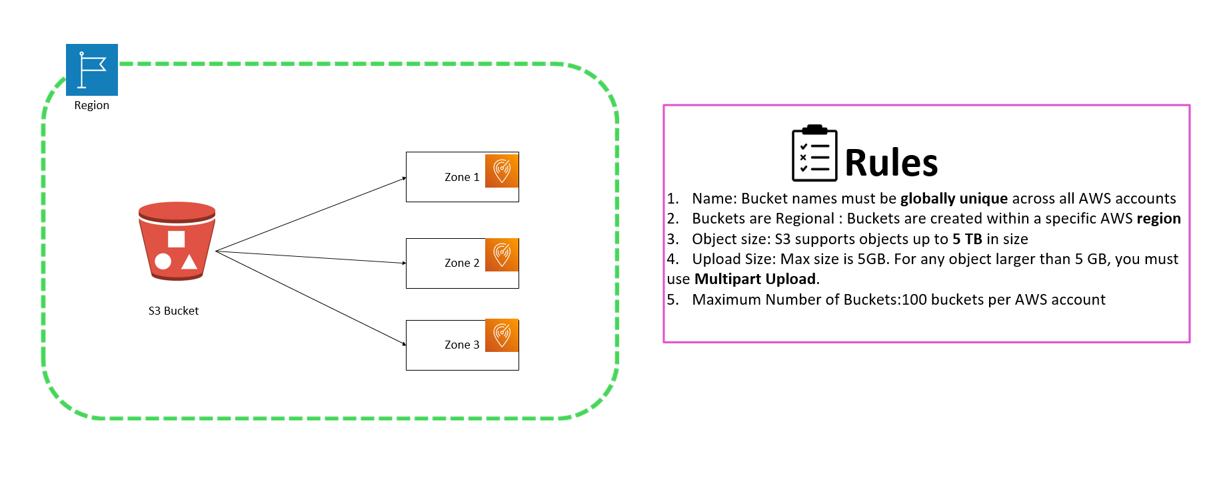

### **High-level steps**

1. In the console's search bar, type "S3" and select **S3** from the search results to open the Amazon S3 dashboard.
2. On the S3 dashboard, click on **Create bucket**.

### **Rules and Policies**

1. Name: Bucket names must be **globally unique** across all AWS accounts
2. Buckets are Regional : Buckets are created within a specific AWS **region**
3. Object size: S3 supports objects up to **5 TB** in size
4. Upload Size: Max size is 5GB. For any object larger than 5 GB, you must use **Multipart Upload**.
5. Maximum Number of Buckets:100 buckets per AWS account

### **Screenshots for S3 Bucket Creation**

In the console's search bar, type "S3" and select **S3** from the search results to open the Amazon S3 dashboard.

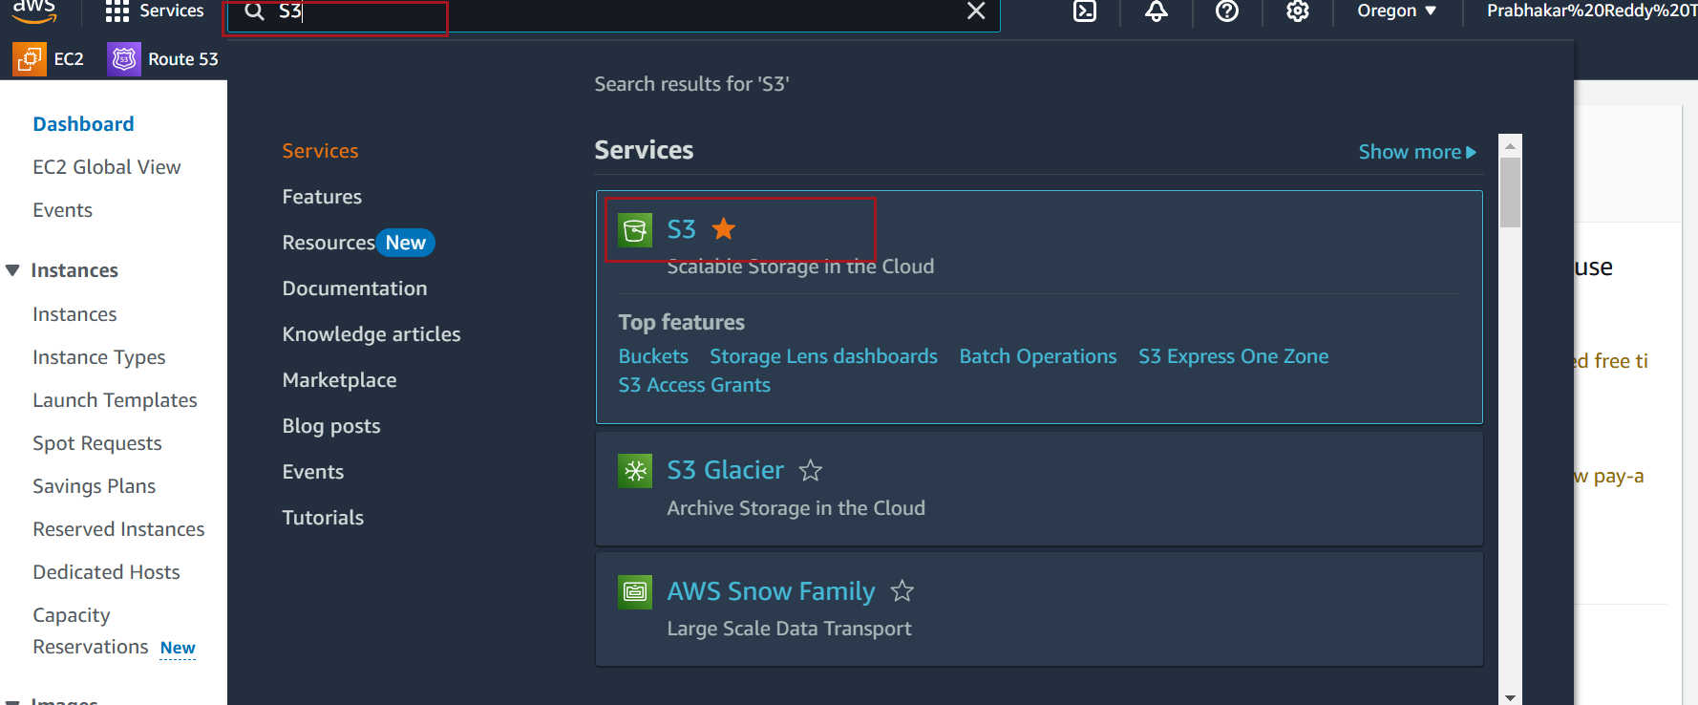

On the S3 dashboard, click on **Create bucket**.

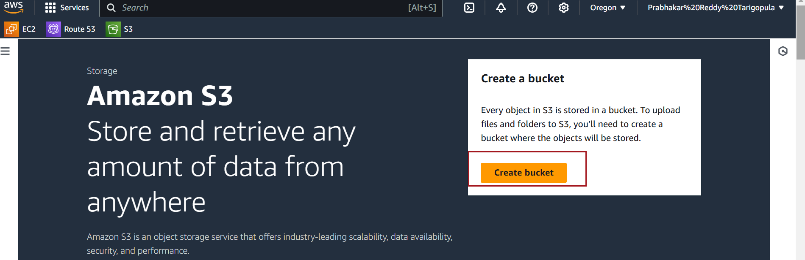

On the **Create bucket** page, you’ll see a **Region** field populated with your current AWS Console region.

If needed, select a different region from the **Region dropdown** to store the bucket in a new location.

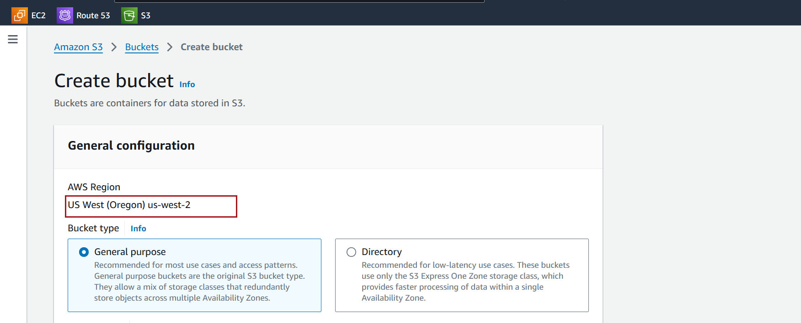

Choose Bucket type

**Bucket Name**: Enter a globally unique name for the bucket that adheres to AWS naming conventions

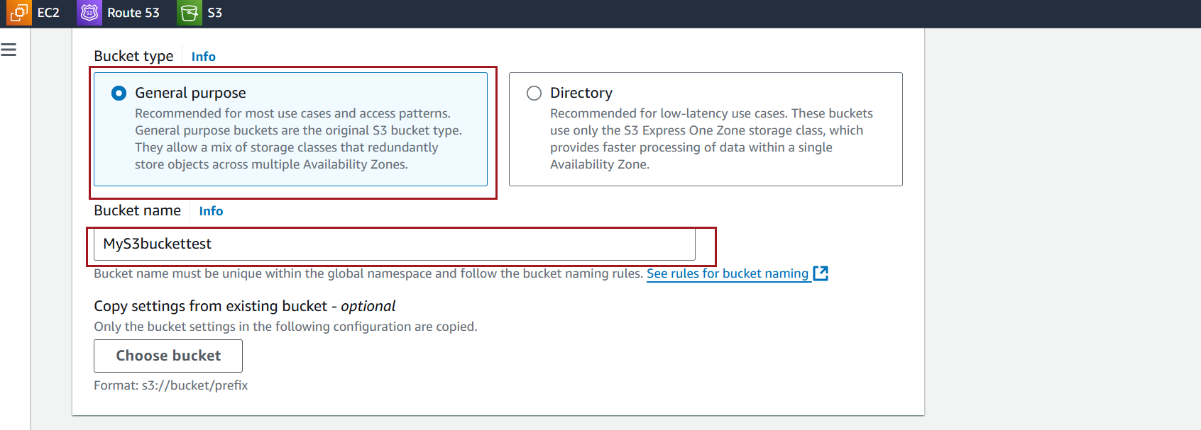

Leave default values for remaining options

Click Create bucket

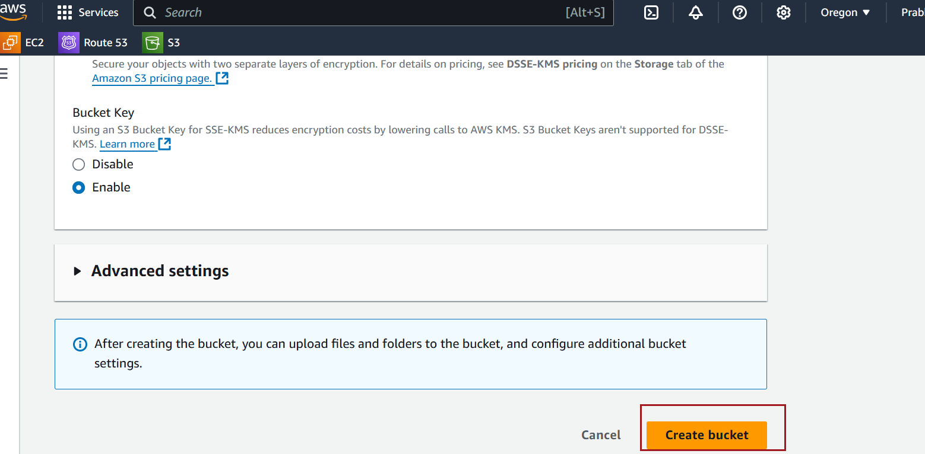

### **Screenshots for Enabling Versioning on an Existing Bucket**

Click on the name of the bucket you want to enable versioning for

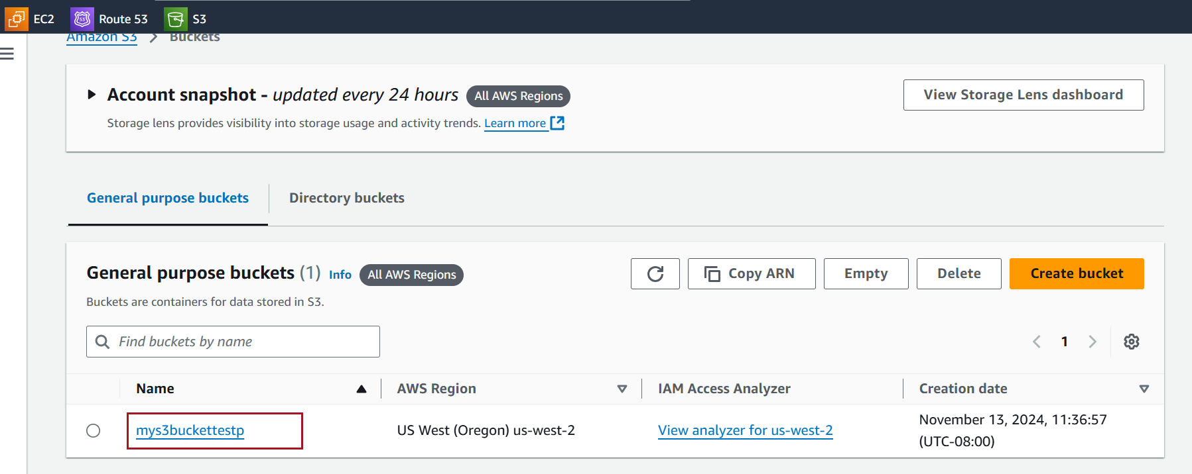

Inside the bucket, navigate to the **Properties** tab

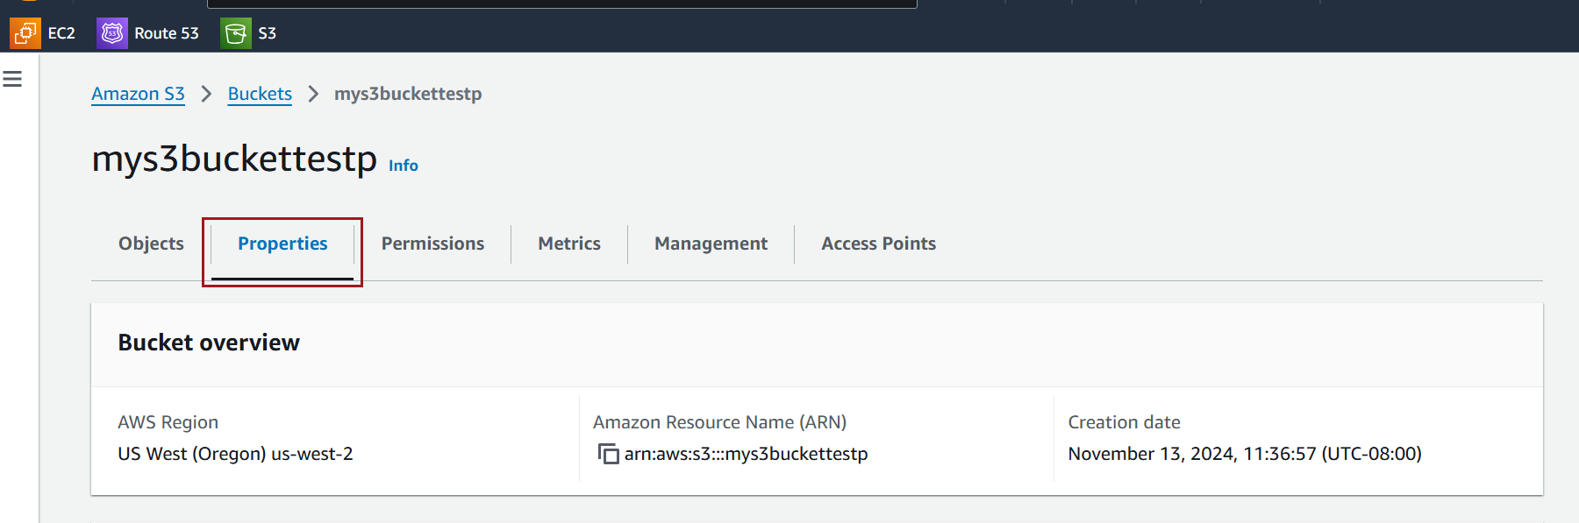

Scroll to the **Versioning** section and click **Edit**.

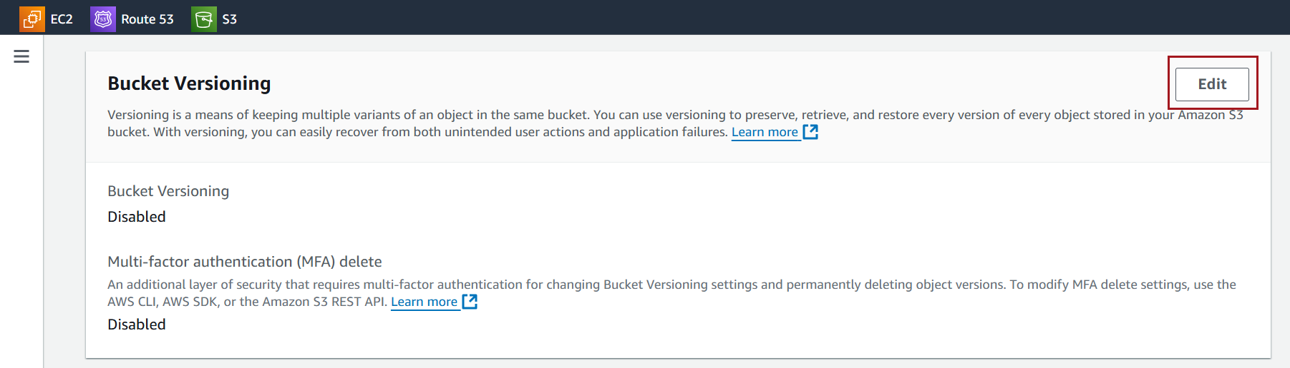

Select **Enable** and click **Save changes**.

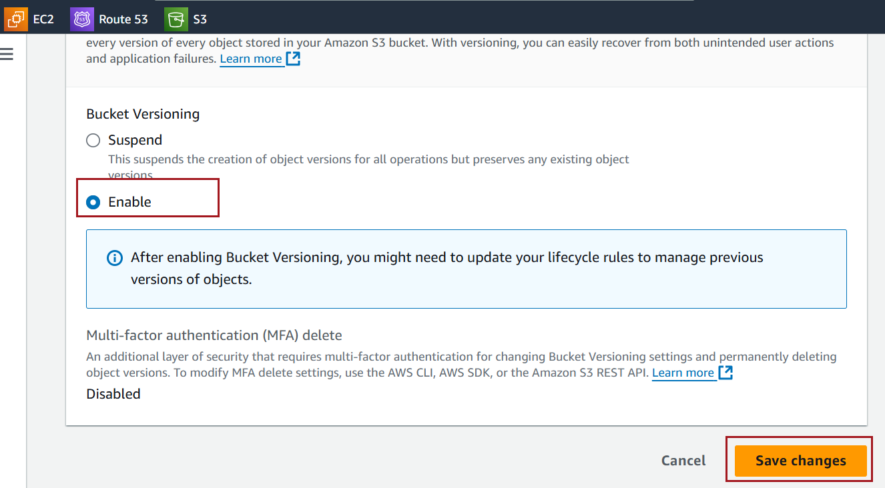

### **Screenshots for checking the versioning**

After enabling versioning on your S3 bucket, follow these steps to upload a file and observe versioning in action

Click on the bucket where versioning has been enabled



In the **Objects** tab, click **Upload**.

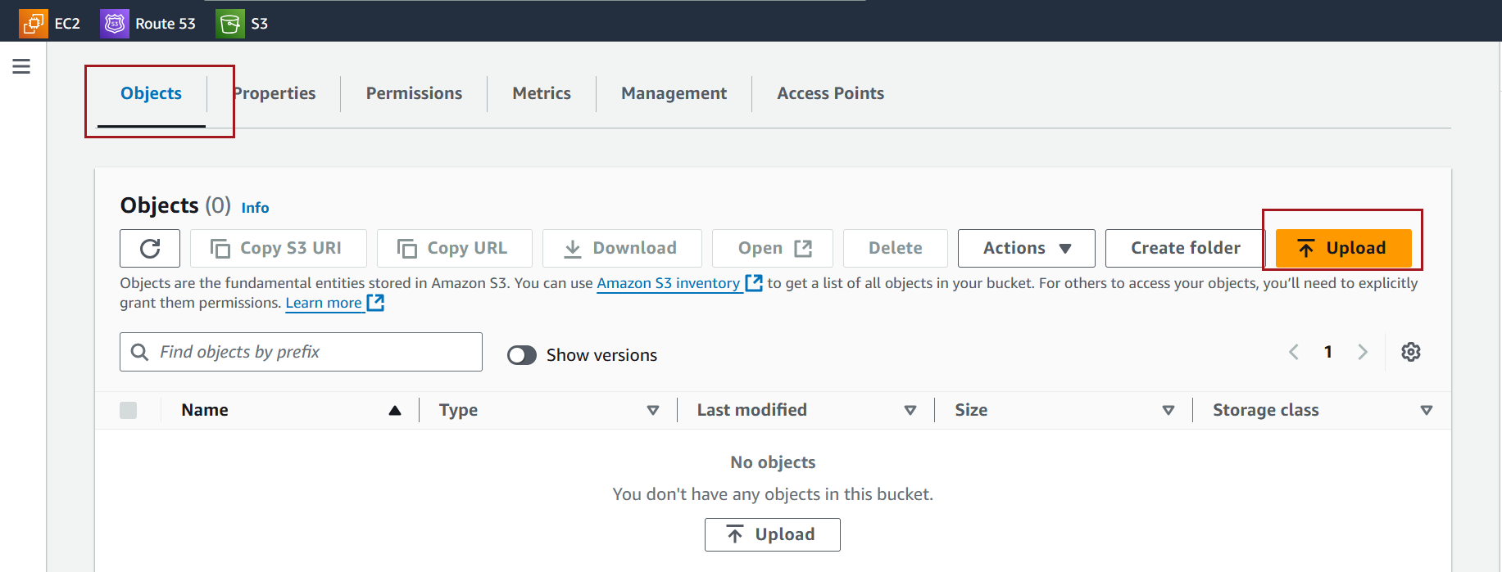

Click Add files to upload a file

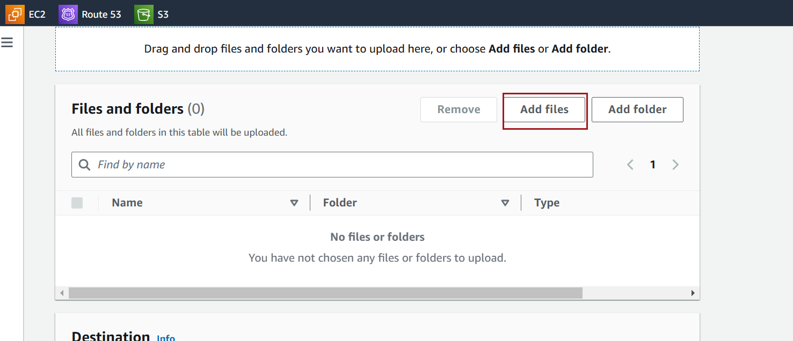

Select the file you want to upload and click **Upload** at the bottom of the page to confirm.

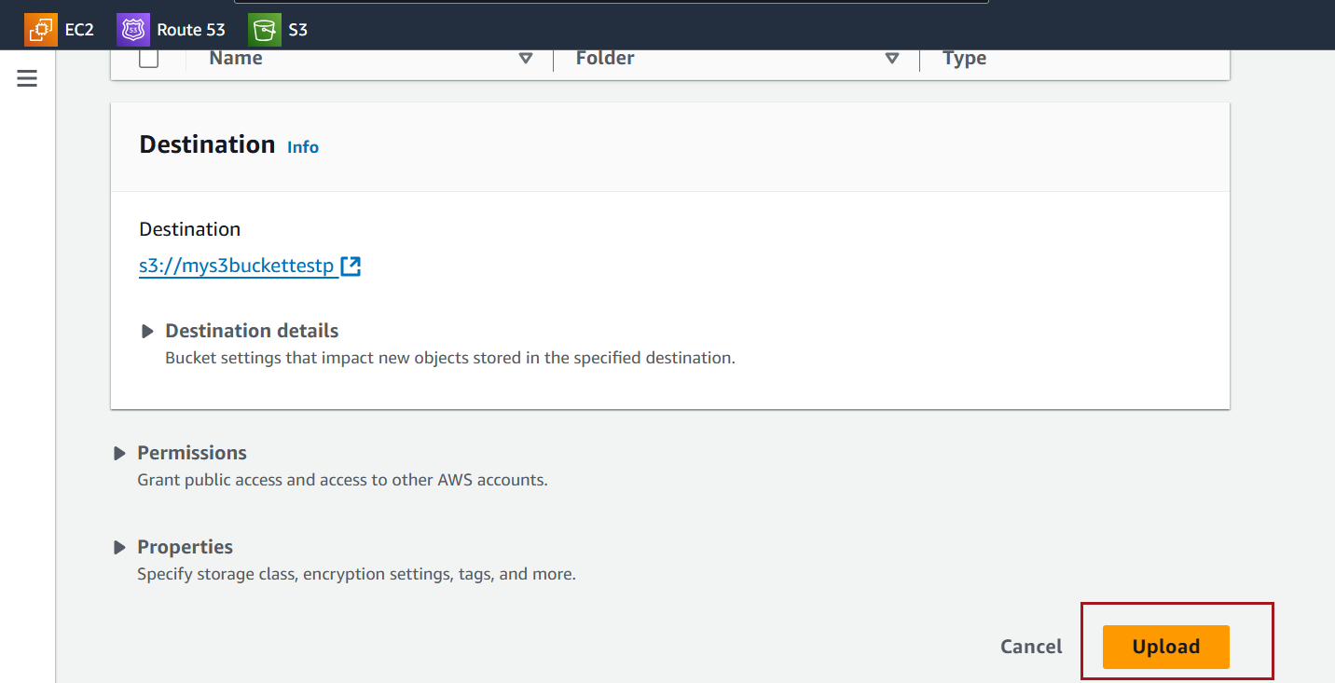

After the upload completes, you’ll see the file listed in the bucket.

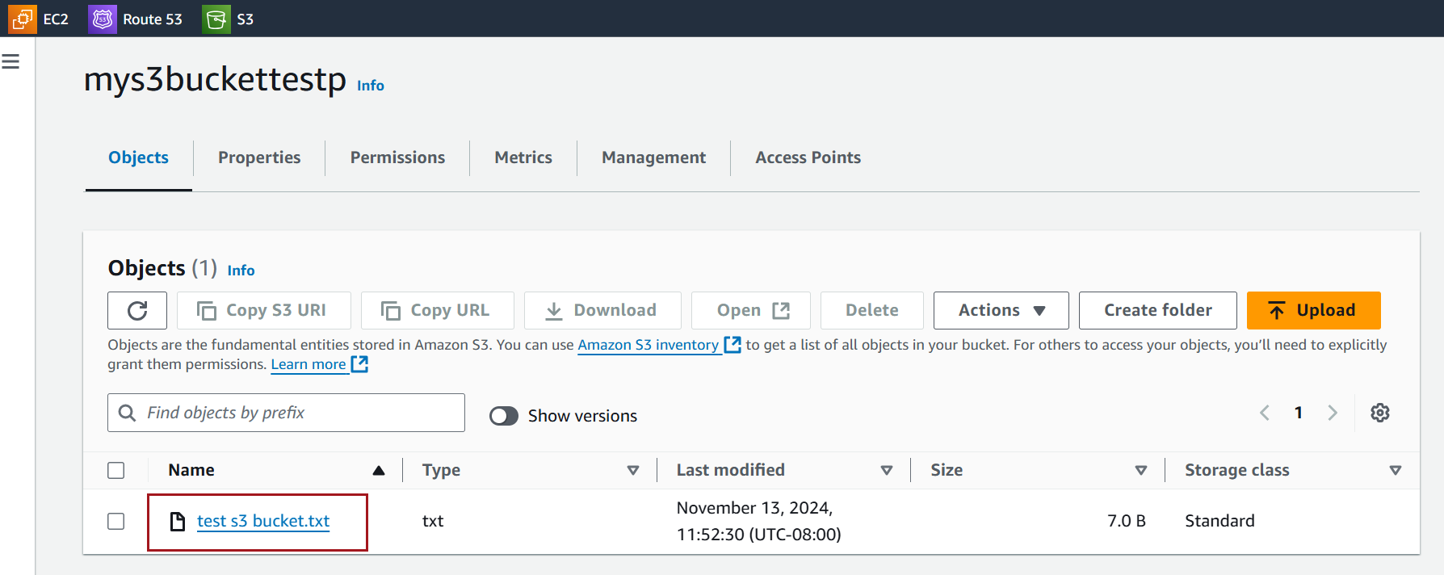

Below is the content in the file

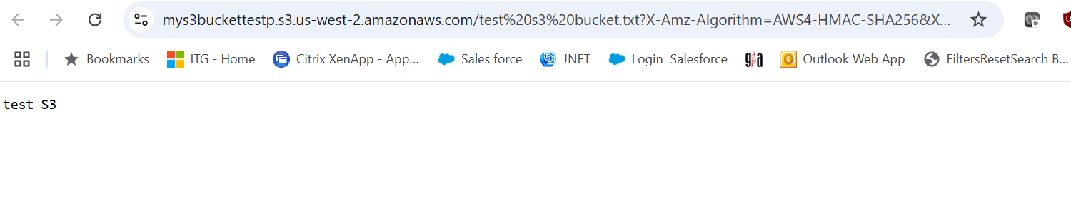

To see versioning in action, you can upload another file with the **same name**. This will create a new version of the file, and both versions will be stored.

Below is the updated content

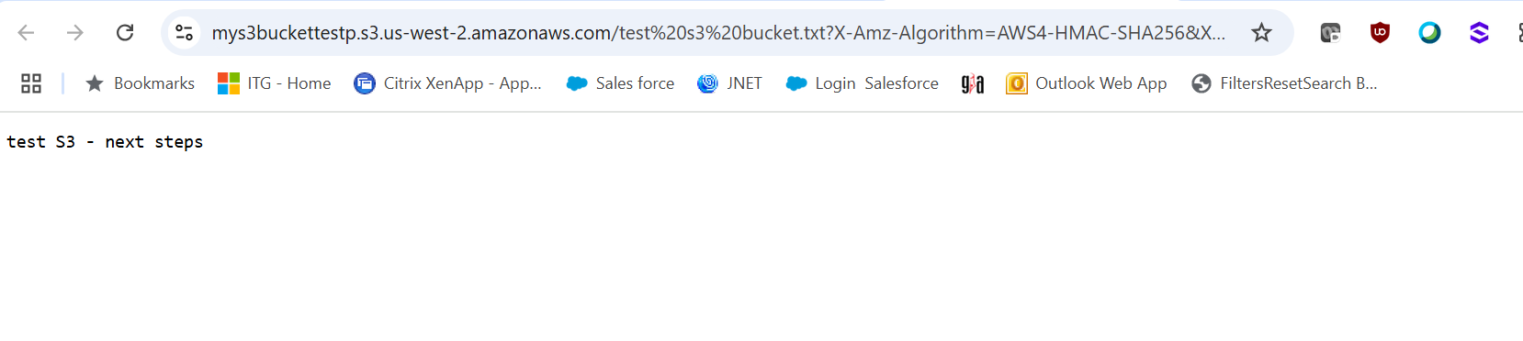

Click the **Show versions** toggle to see both versions of the file with unique version IDs.

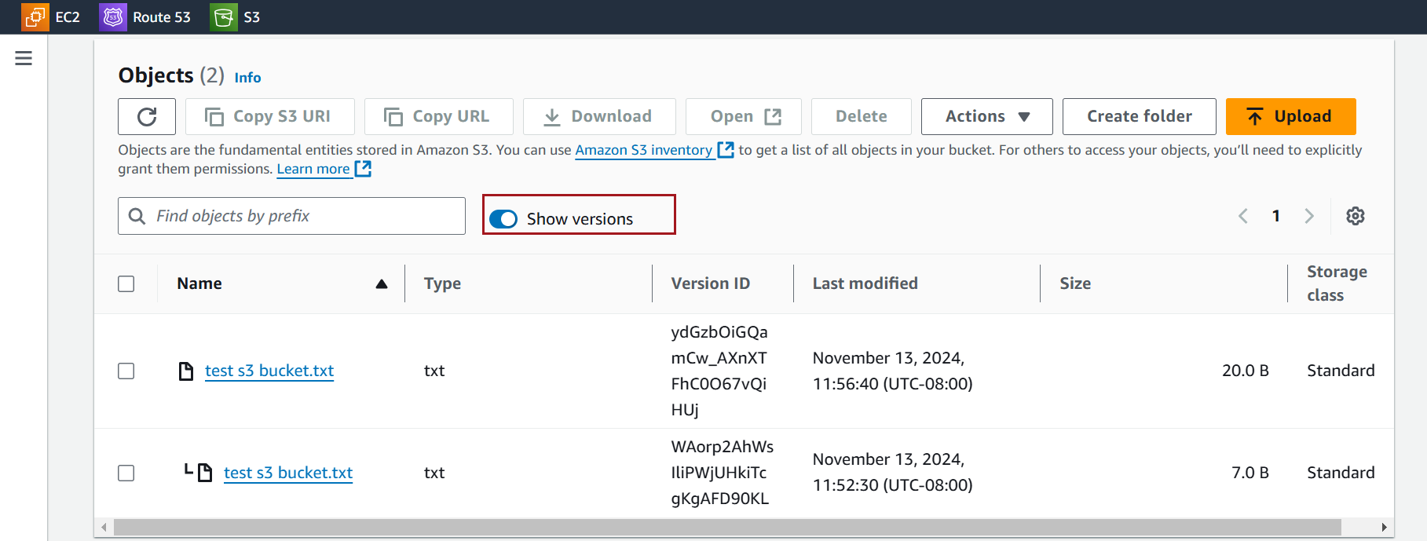

### **Screenshots for Recovering a Deleted File**

Navigate to the bucket where versioning is enabled

In the **Objects** tab, Select the specific object you want to delete.

Click **Delete**

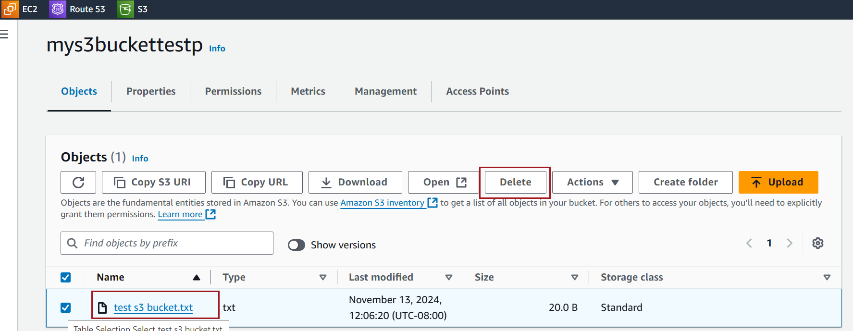

confirm the deletion

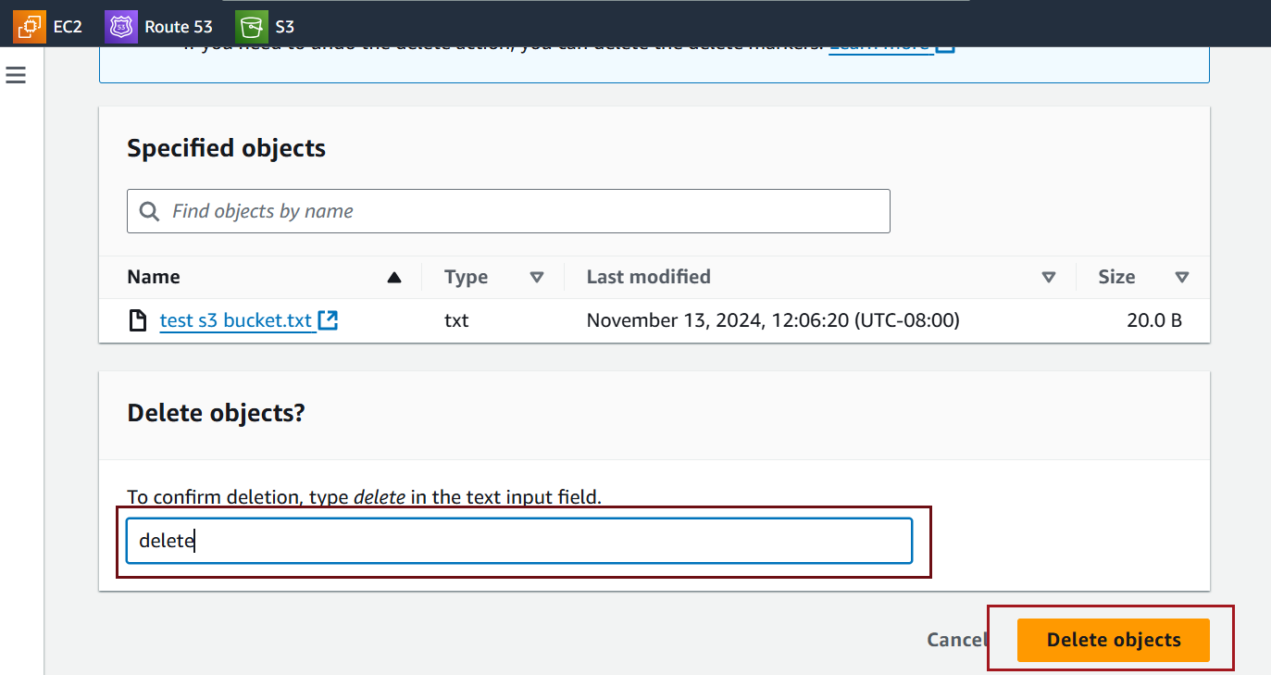

enable **Show versions**

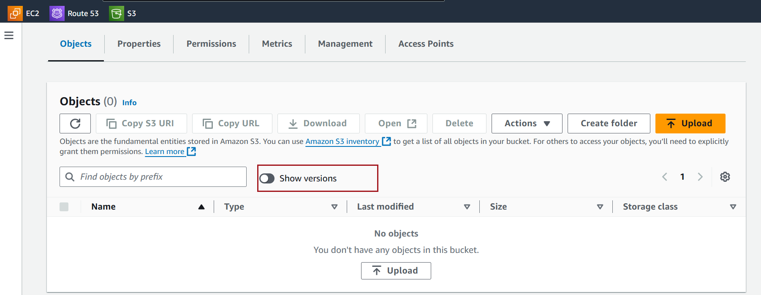

Amazon S3 will add a **delete marker** to the object instead of permanently deleting it. This makes the object appear deleted in the bucket’s default view.

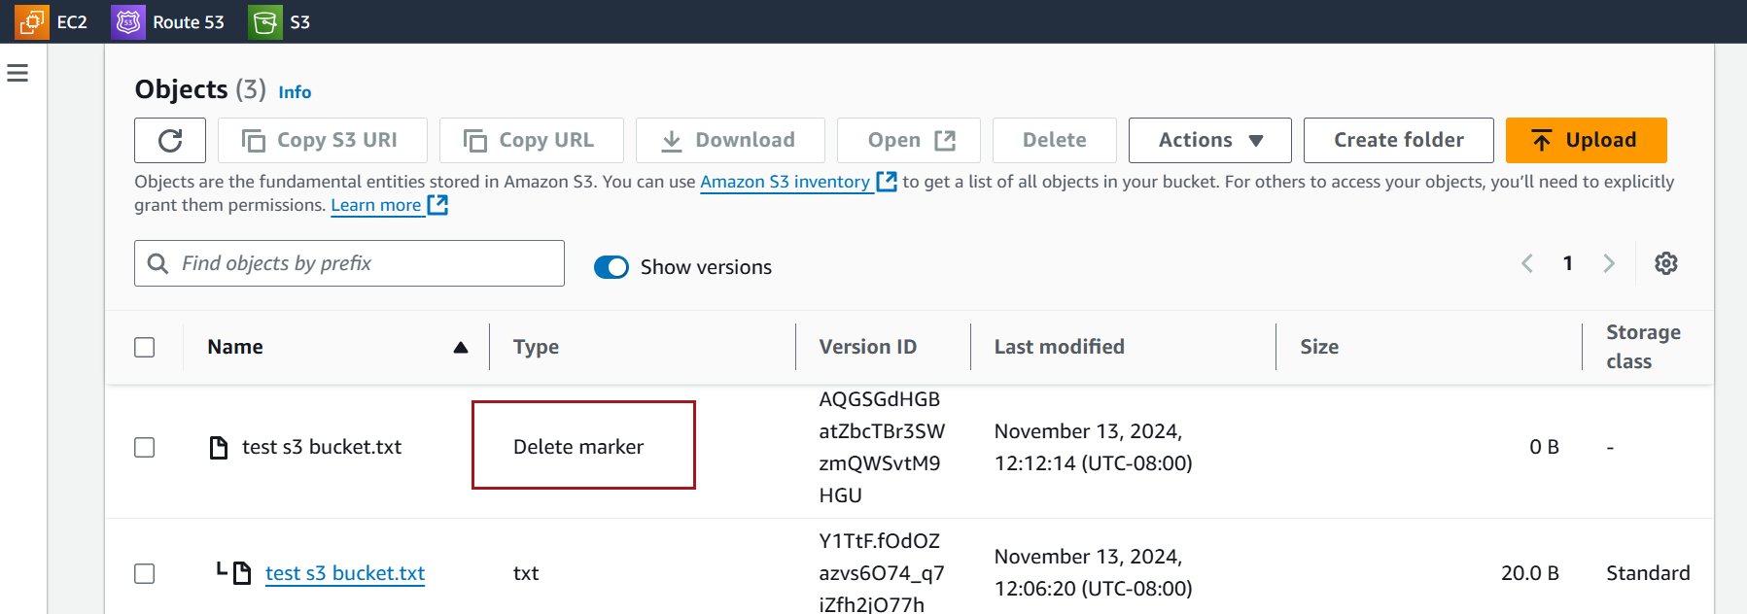

Locate the delete marker for the object

Select and delete the delete marker.

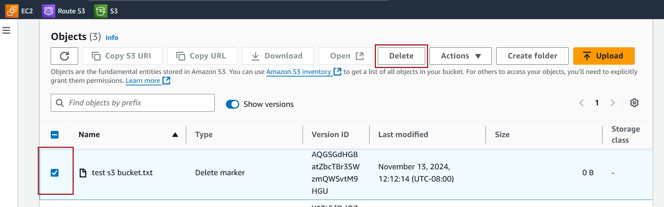

Confirm deletion

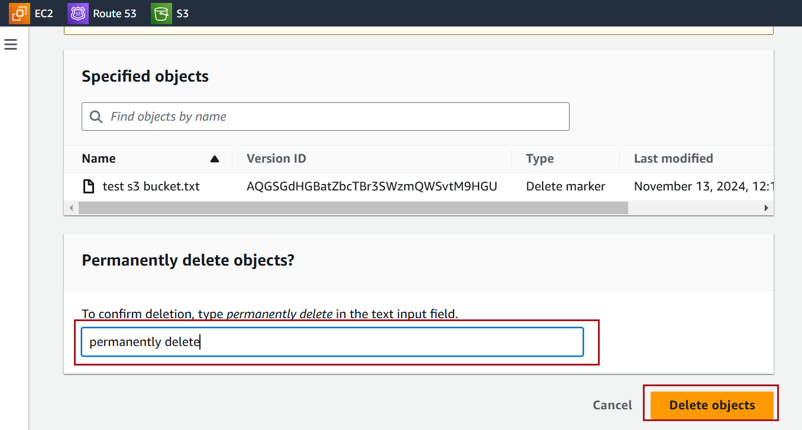

Observe that restores the object's visibility, effectively "undeleting" it.

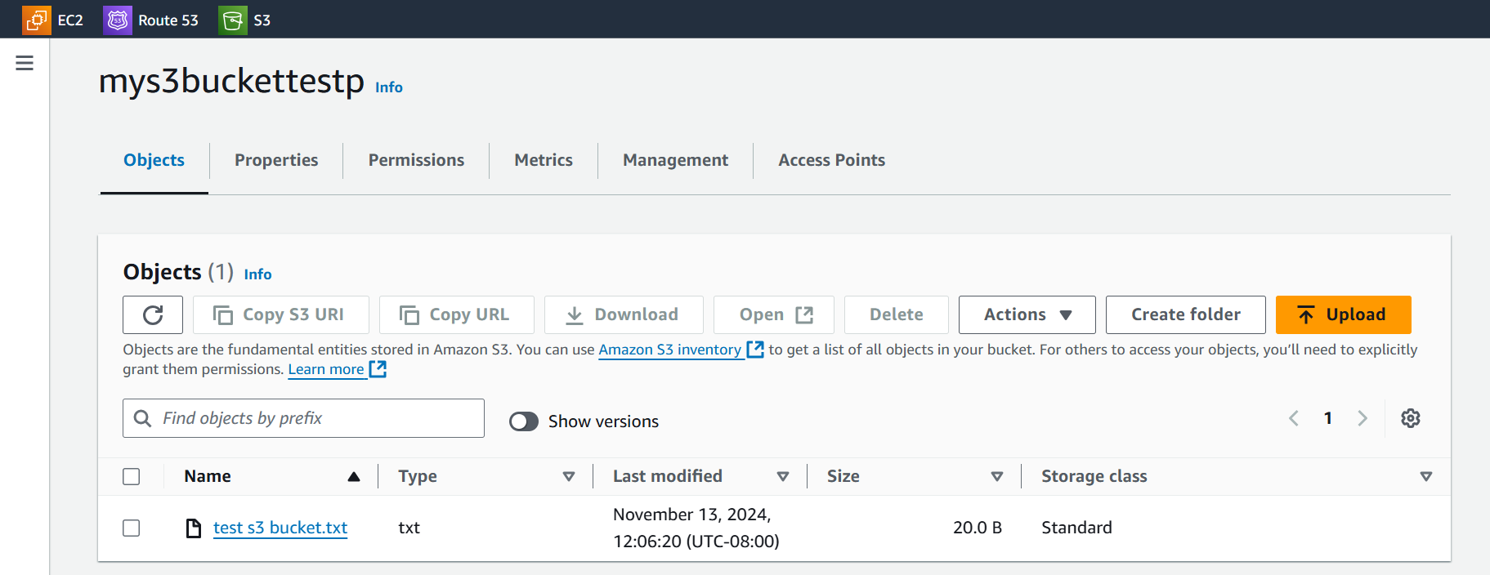

### **Screenshot for to Set Up Replication in S3**

In the S3 console, select the bucket you want to use as the source bucket for replication

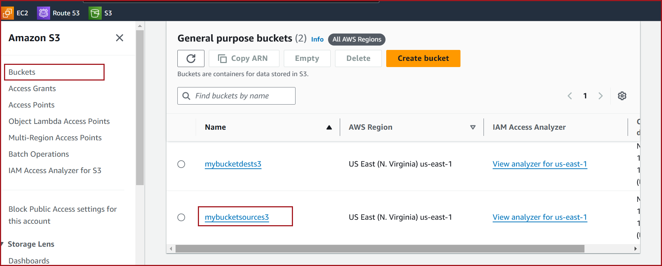

Go to the **Management** tab in your source bucket

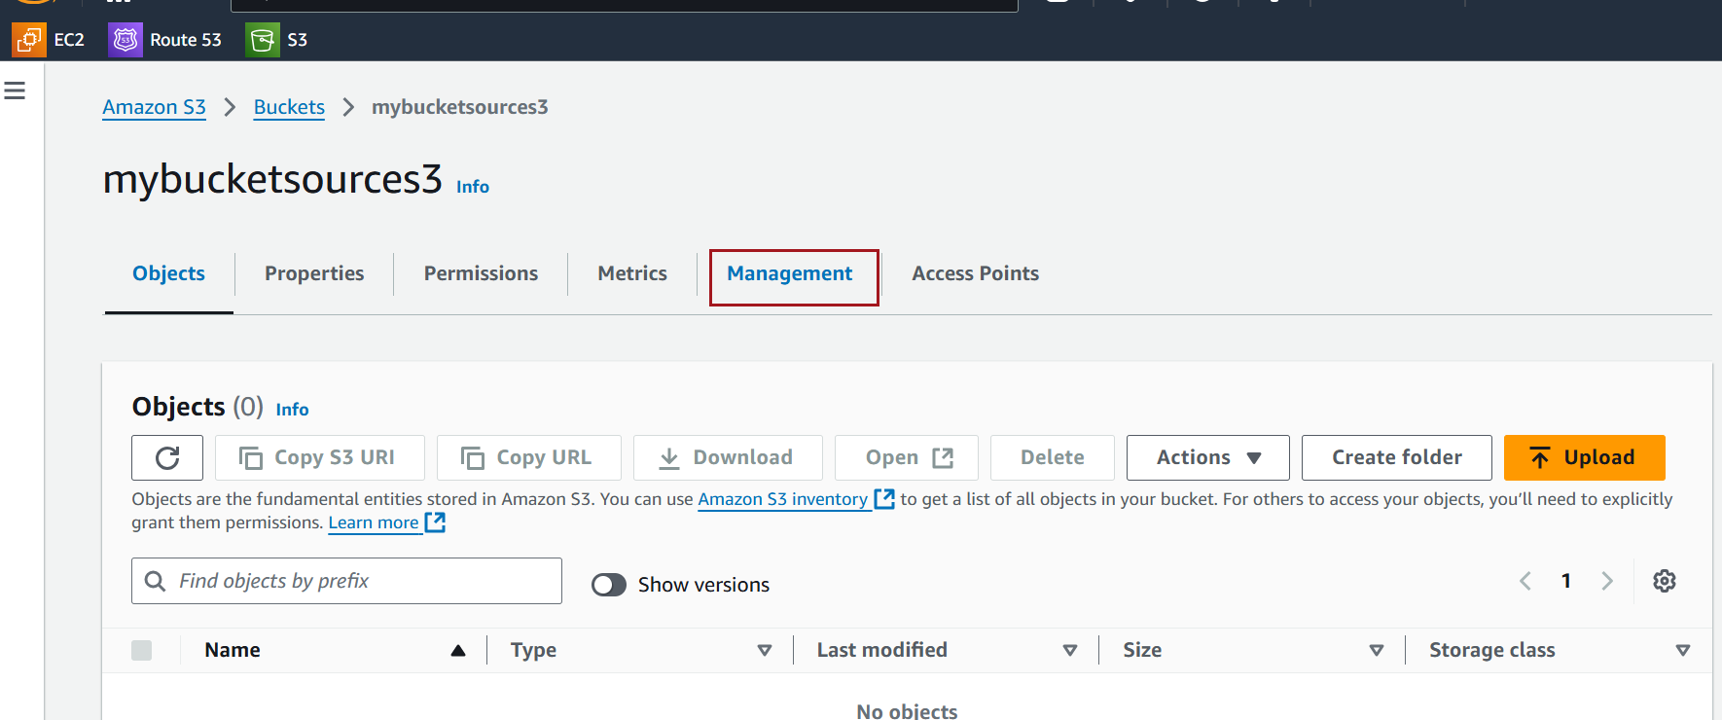

Click **Create replication rule**

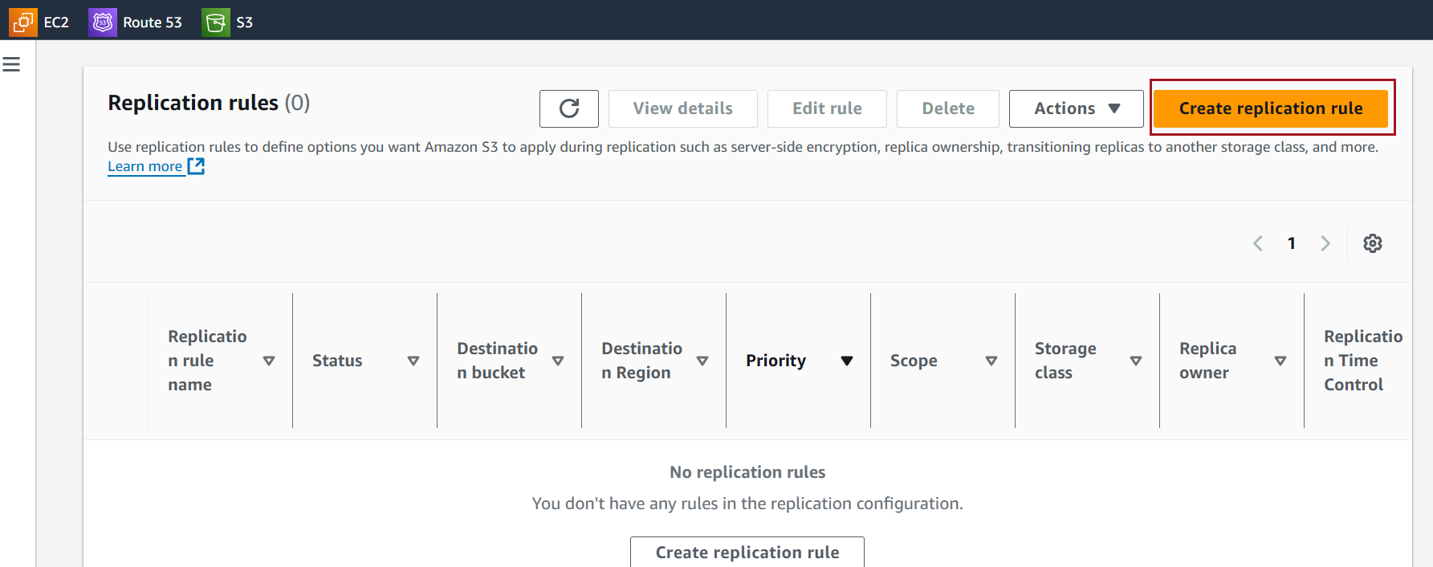

Enter a name for the rule.

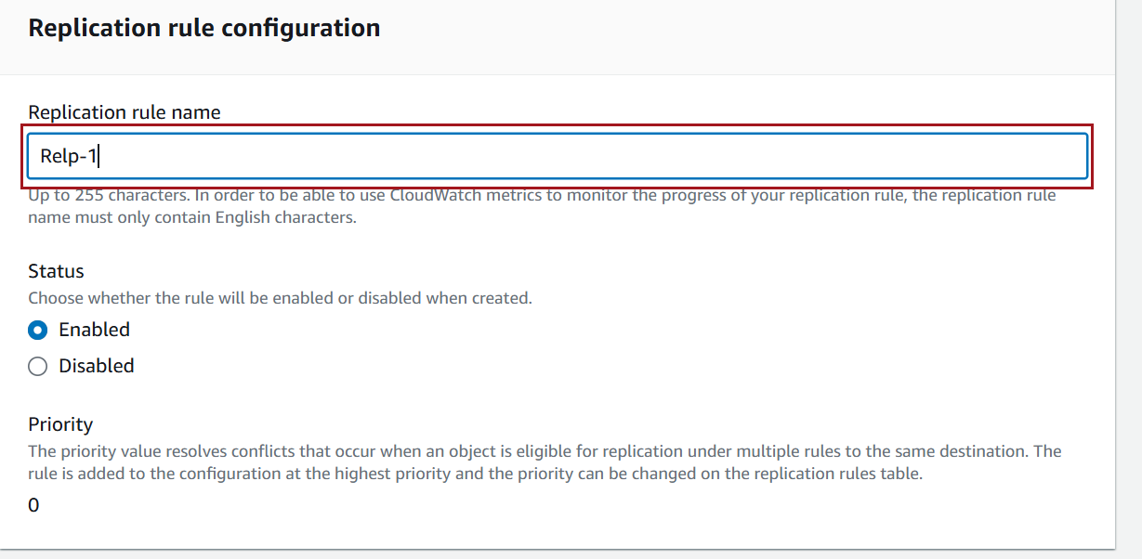

You can choose to replicate the entire bucket or use filters (prefixes or tags) to replicate specific objects.

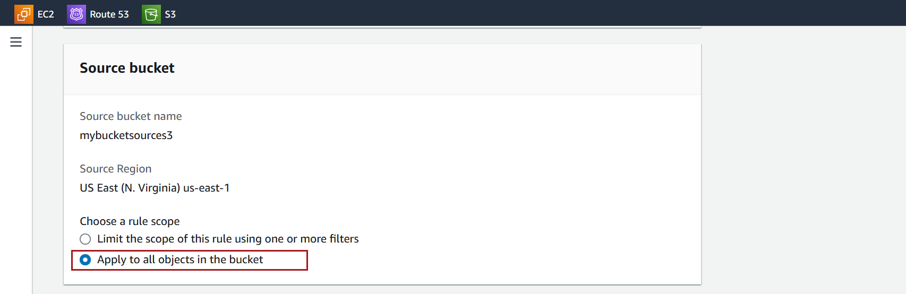

Choose a destination bucket, which can be in the same or a different region. If it’s in a different account, enter the account ID.

Enable Versioning

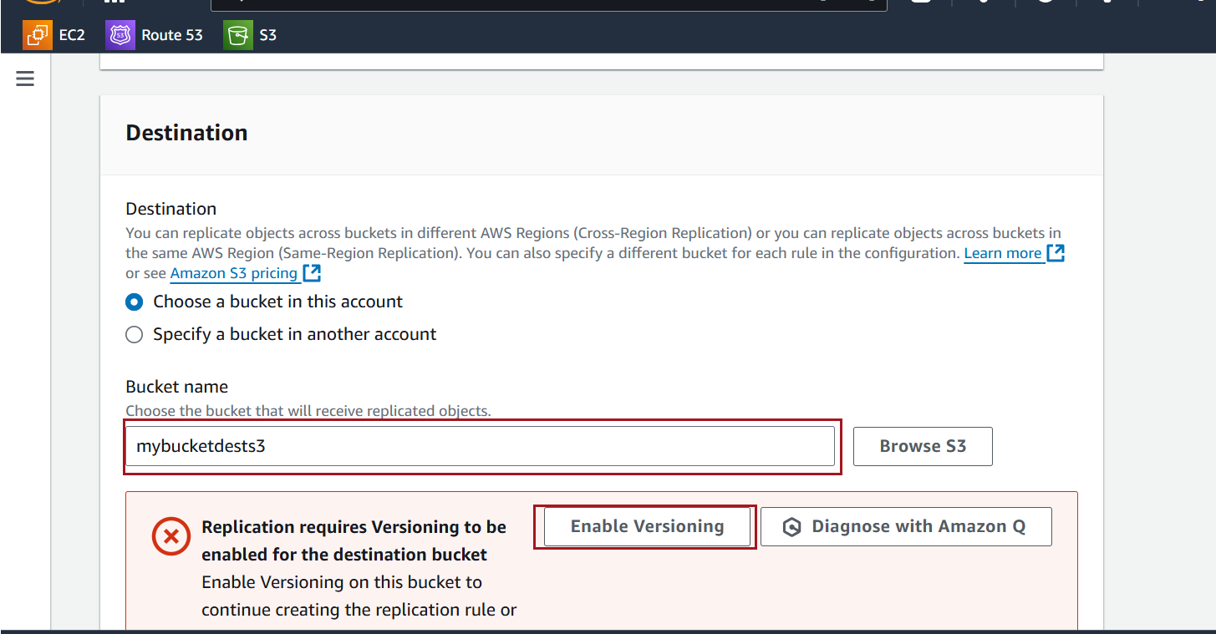

AWS will prompt you to create or select an IAM role that allows replication. AWS can create the role automatically, or you can choose an existing one if you have it set up.

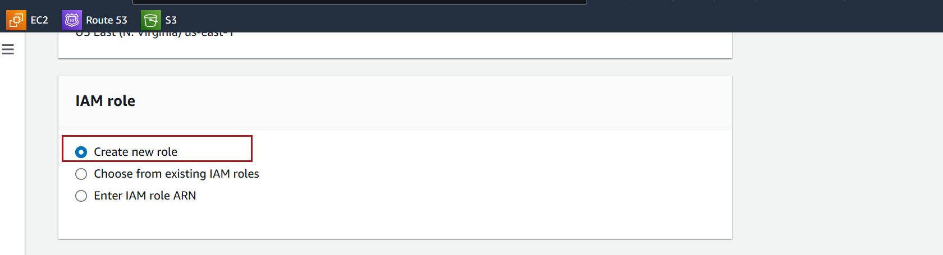

Click on Save

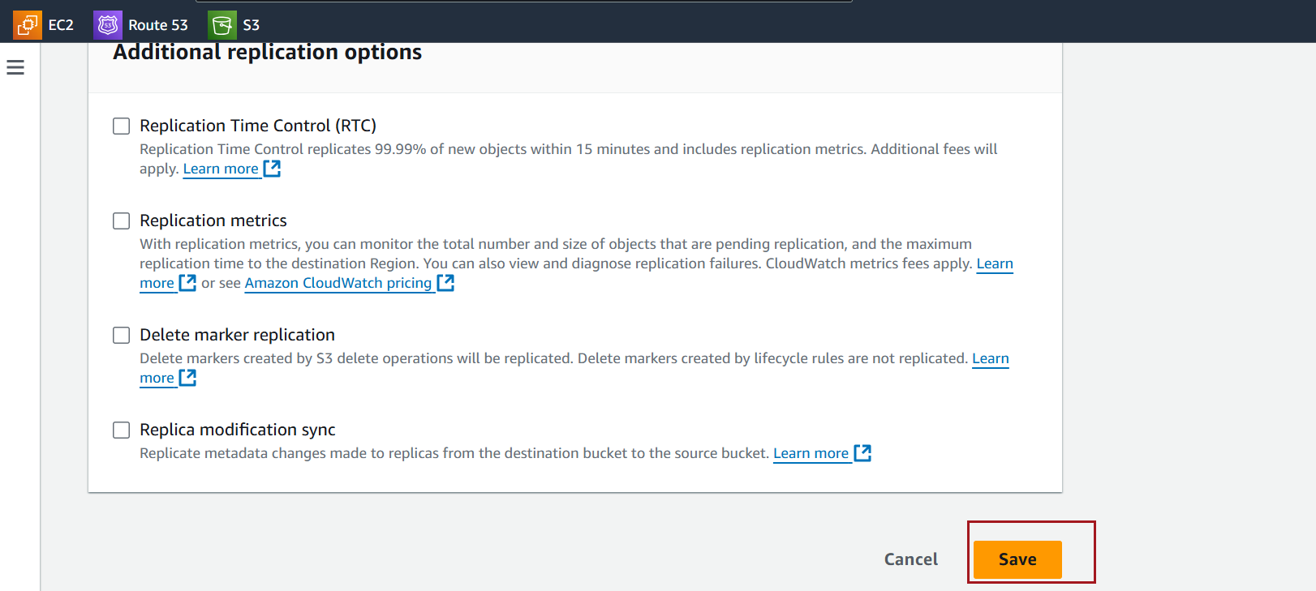

**No, Do Not Replicate Existing Objects:**

* If you select this option, only new objects added to the source bucket after the replication rule is set up will be replicated to the destination bucket.

**Yes, Replicate Existing Objects**:

* If you choose this option, Amazon S3 will replicate both **new and existing objects** in the source bucket to the destination bucket.

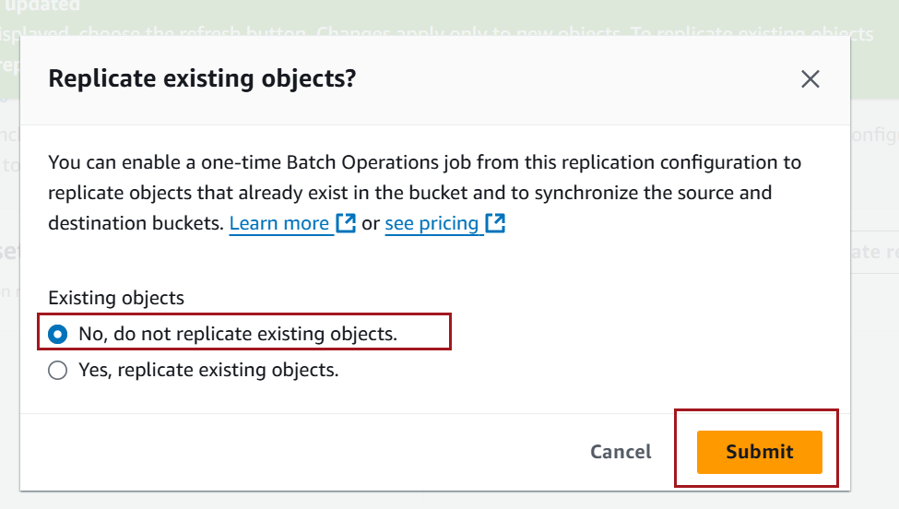

**Test Replication**:

Upload a new object to the source bucket.

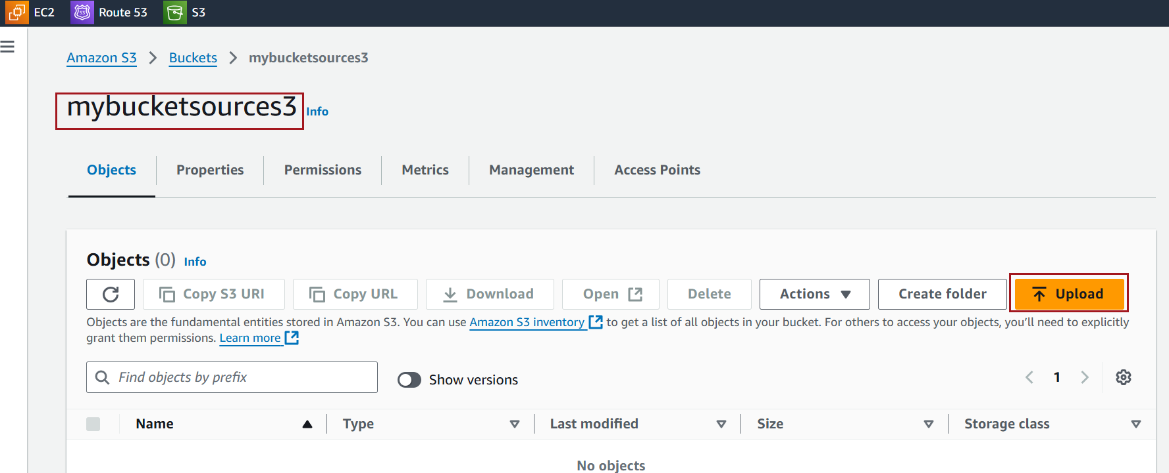

Click on Add Files to add files

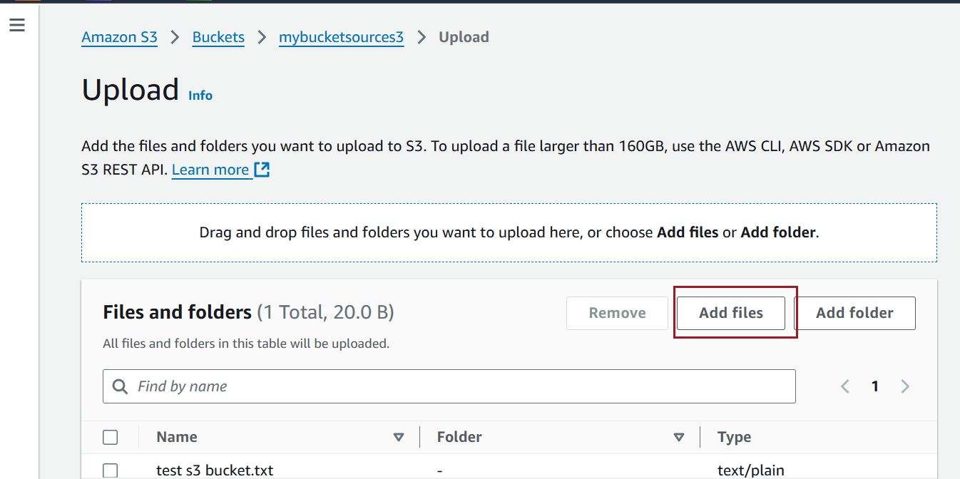

Observer that file is added

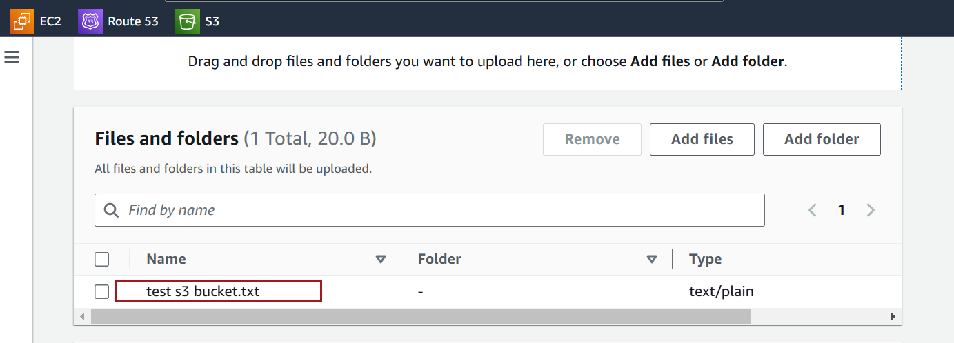

Click on Upload

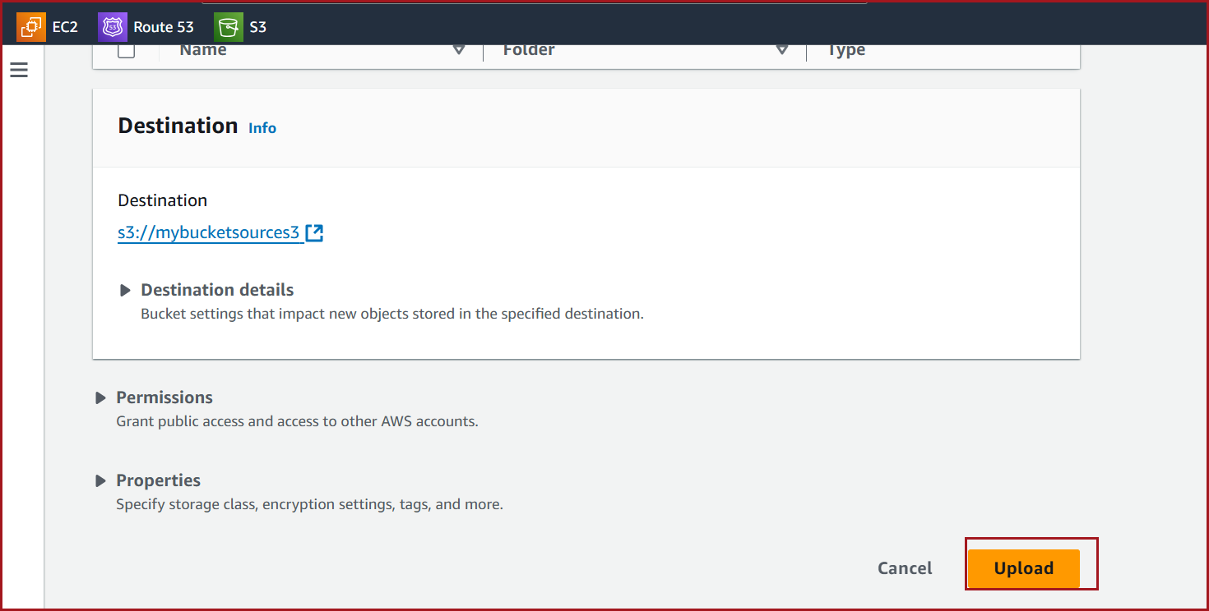

Observer that file is available in Source bucket

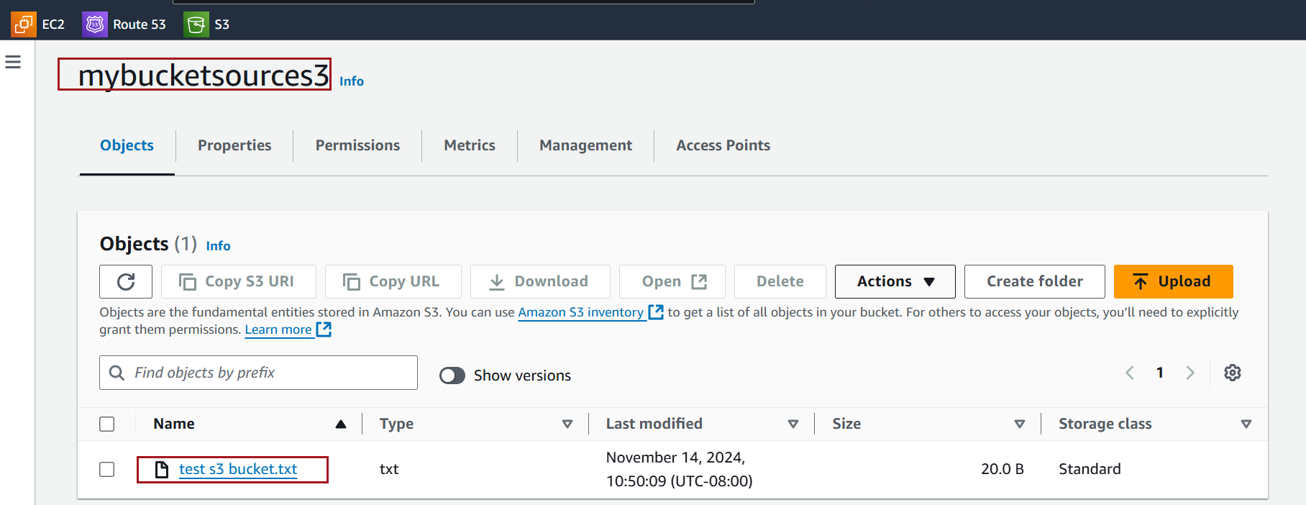

select the bucket you want to use as the destination bucket configured in replication

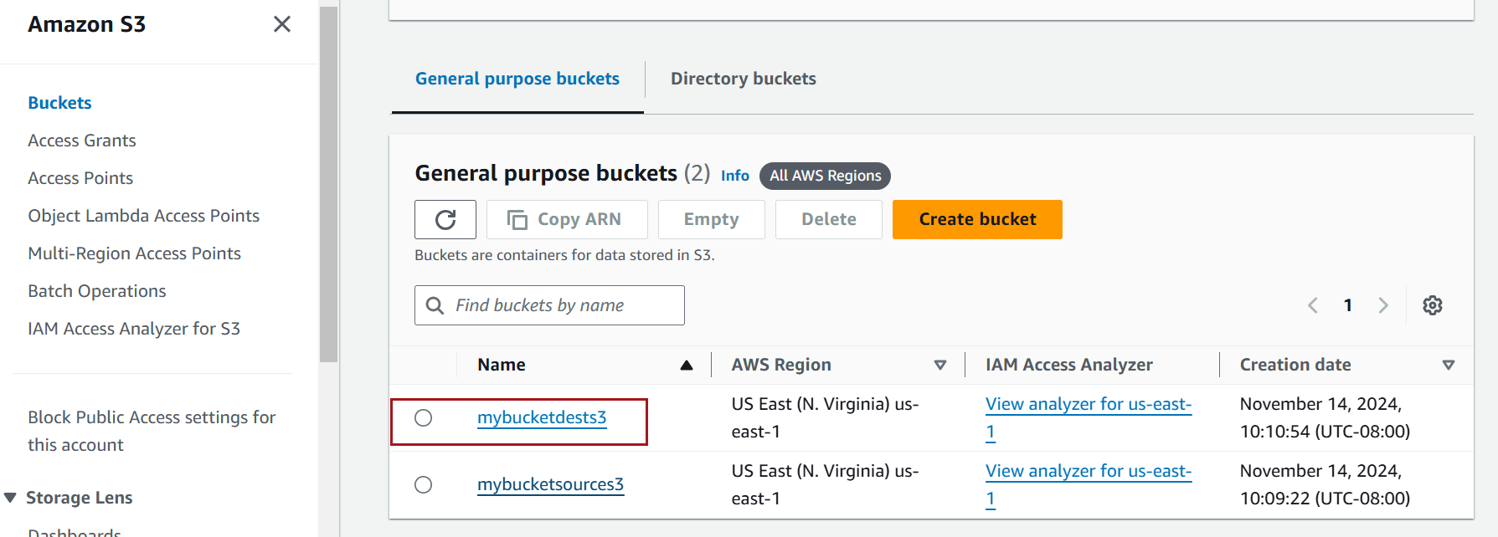

The file is available in destination bucket too

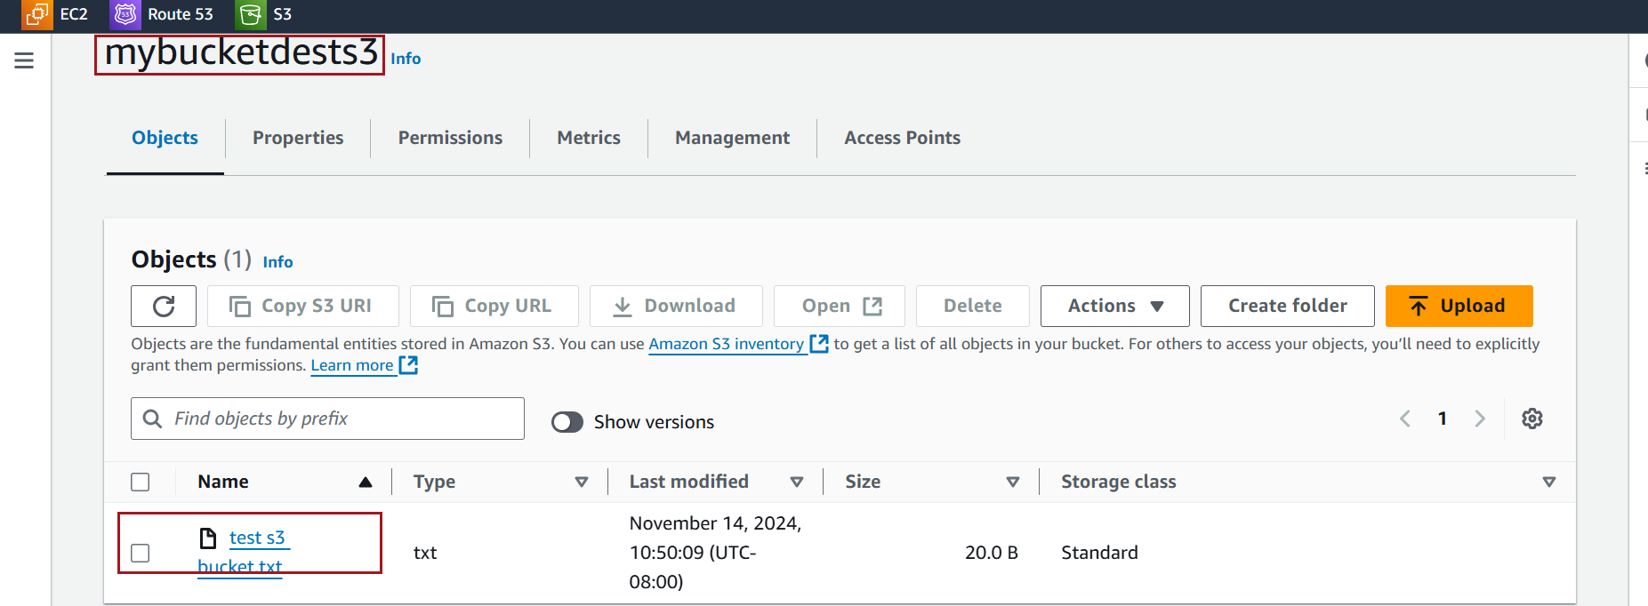

### **Screenshot for Providing Public Access to a File in S3**

In order to provide **read access** to a file in Amazon S3 (S3), you must ensure that **Block Public Access** is turned off for the bucket or configured appropriately. AWS S3 buckets have **Block Public Access settings** that can prevent any public access, even if permissions or bucket policies are set to allow it.

Click on the bucket that contains the file you want to make publicly accessible

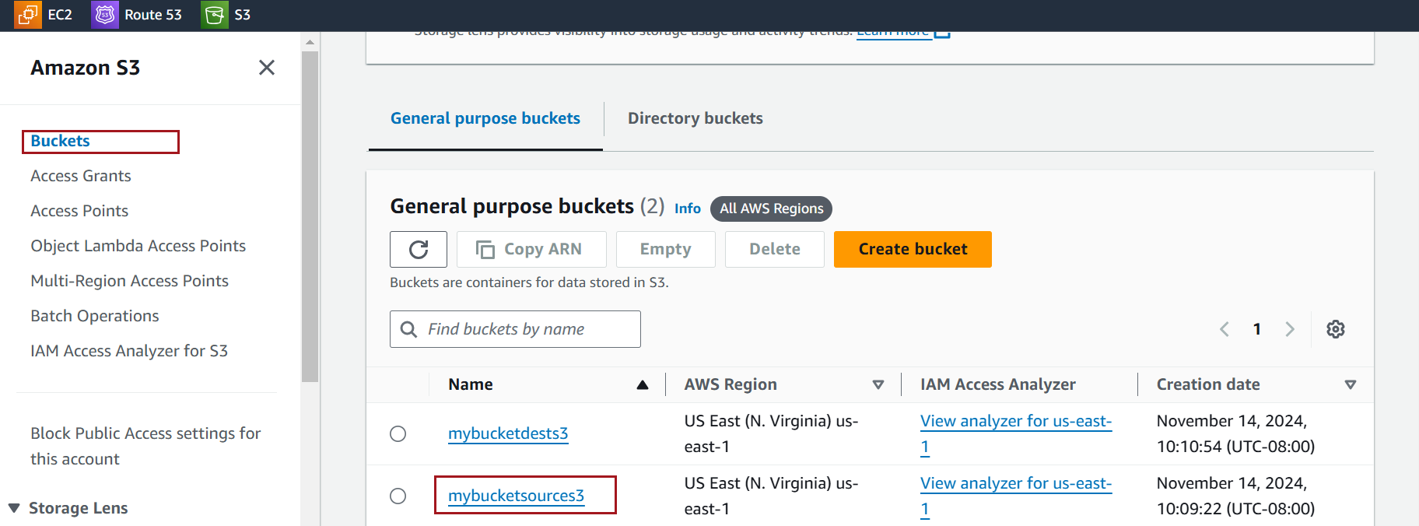

Click on the Permissions

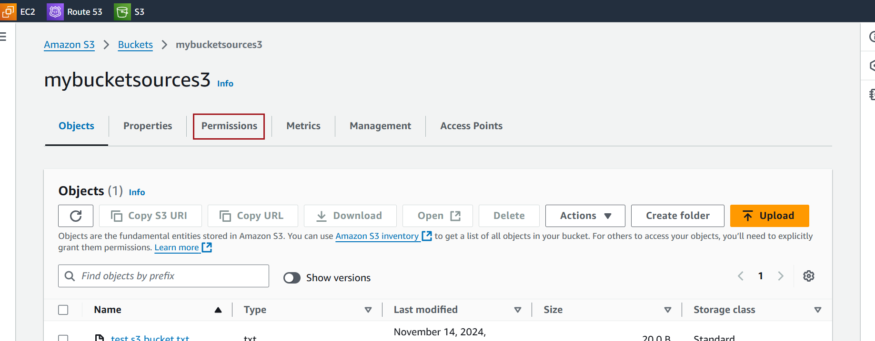

At the top, you’ll see the **Block Public Access (Bucket Settings)** section.

Click **Edit** to adjust these settings

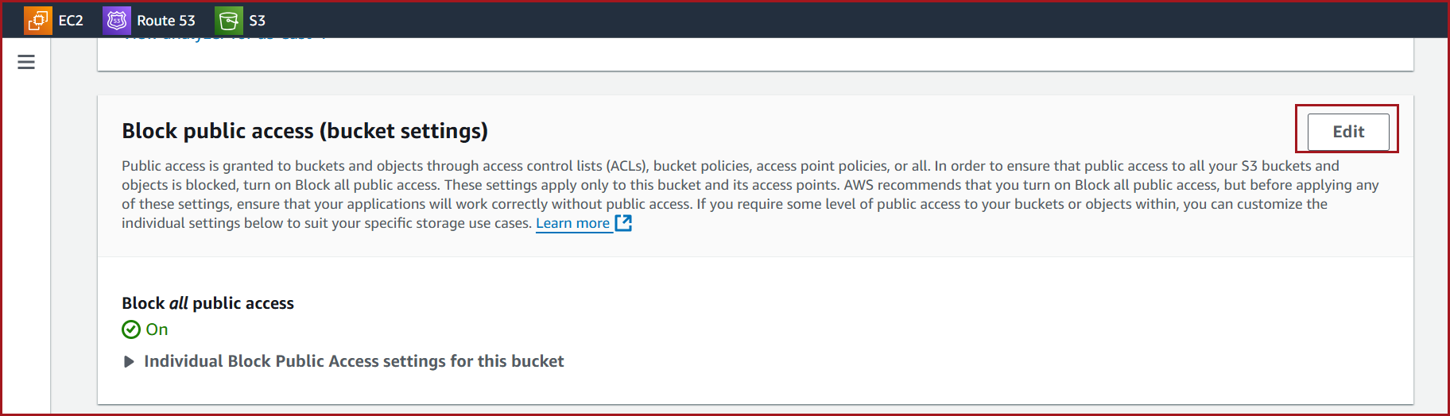

**uncheck** **Block all public access** Confirm by clicking **Save changes**.

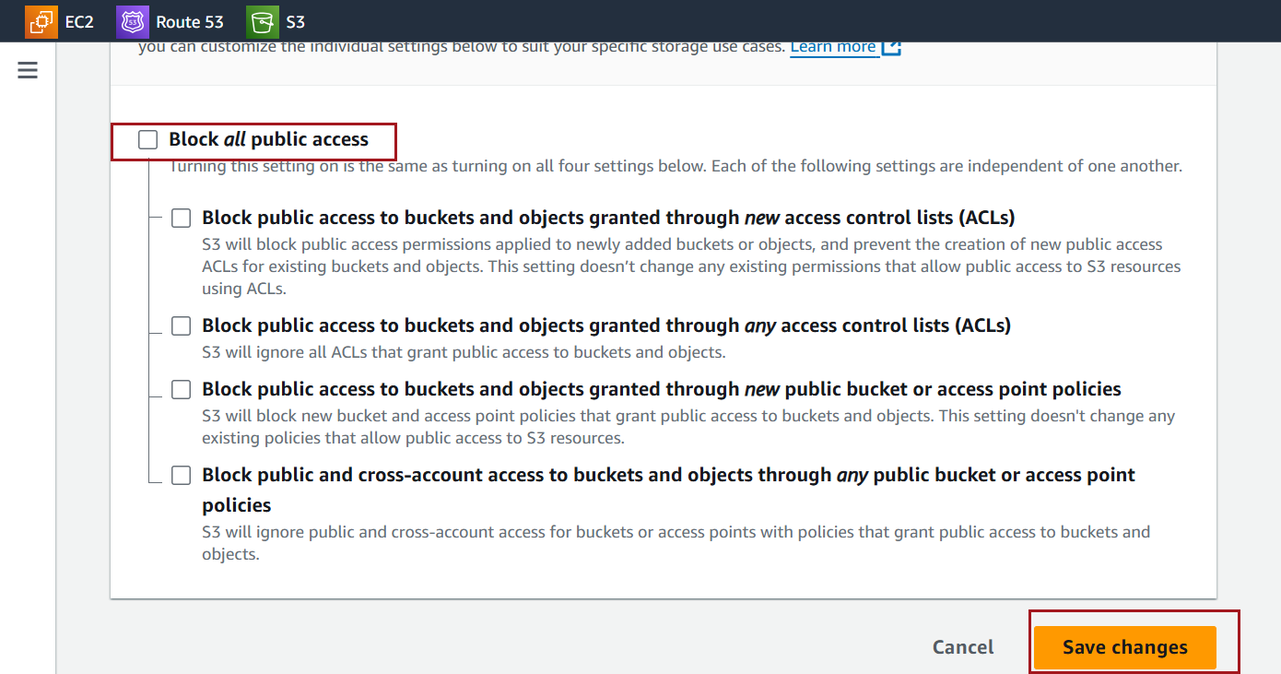

To provide **read access** to a file in Amazon S3, it's also important to ensure that **Access Control Lists (ACLs)** are enabled.

Go to the **Permissions** tab of the bucket.



Click on **Object Ownership** setting.

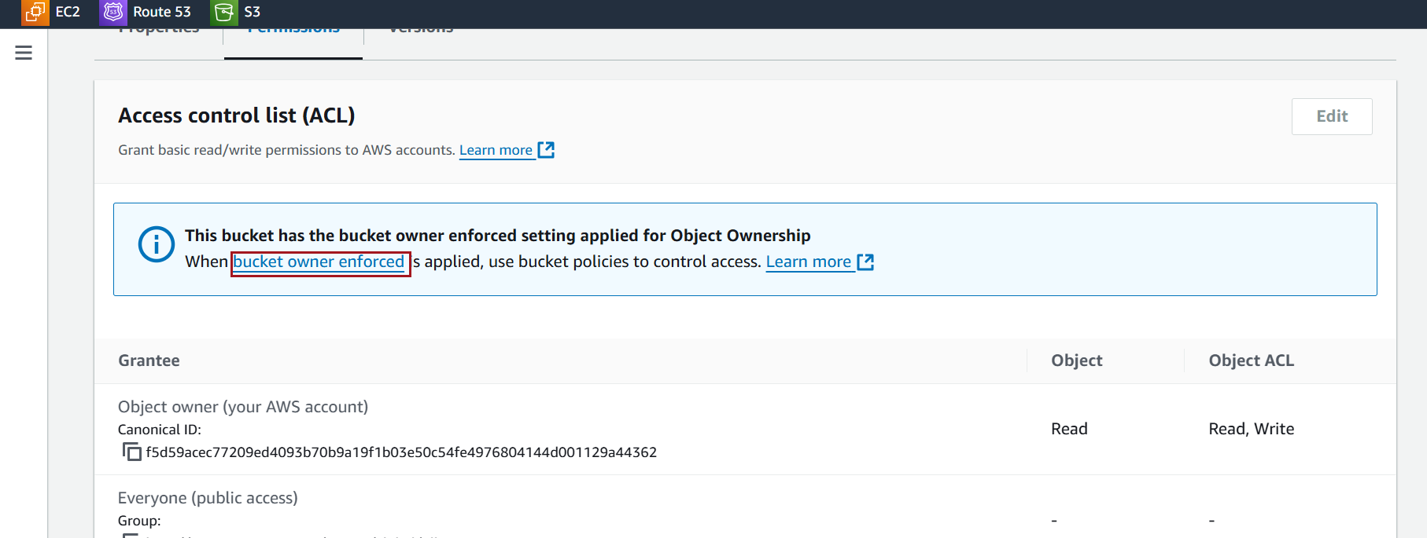

Enable the ACLs

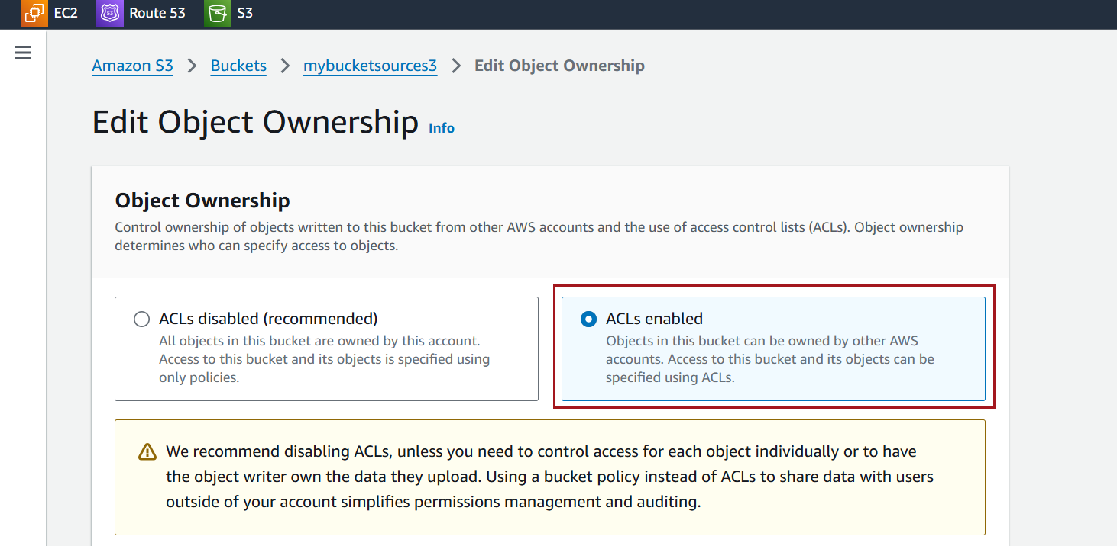

Acknowledge that ACLs will be restored and Click on save changes

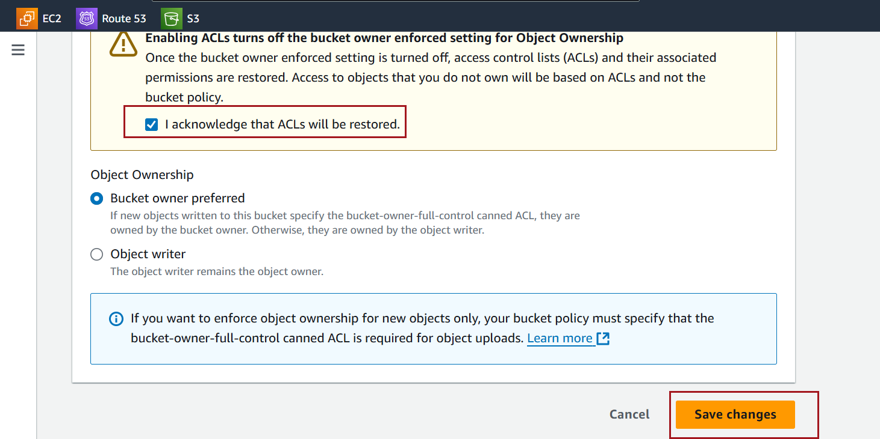

Select the file (object) and Click on Action

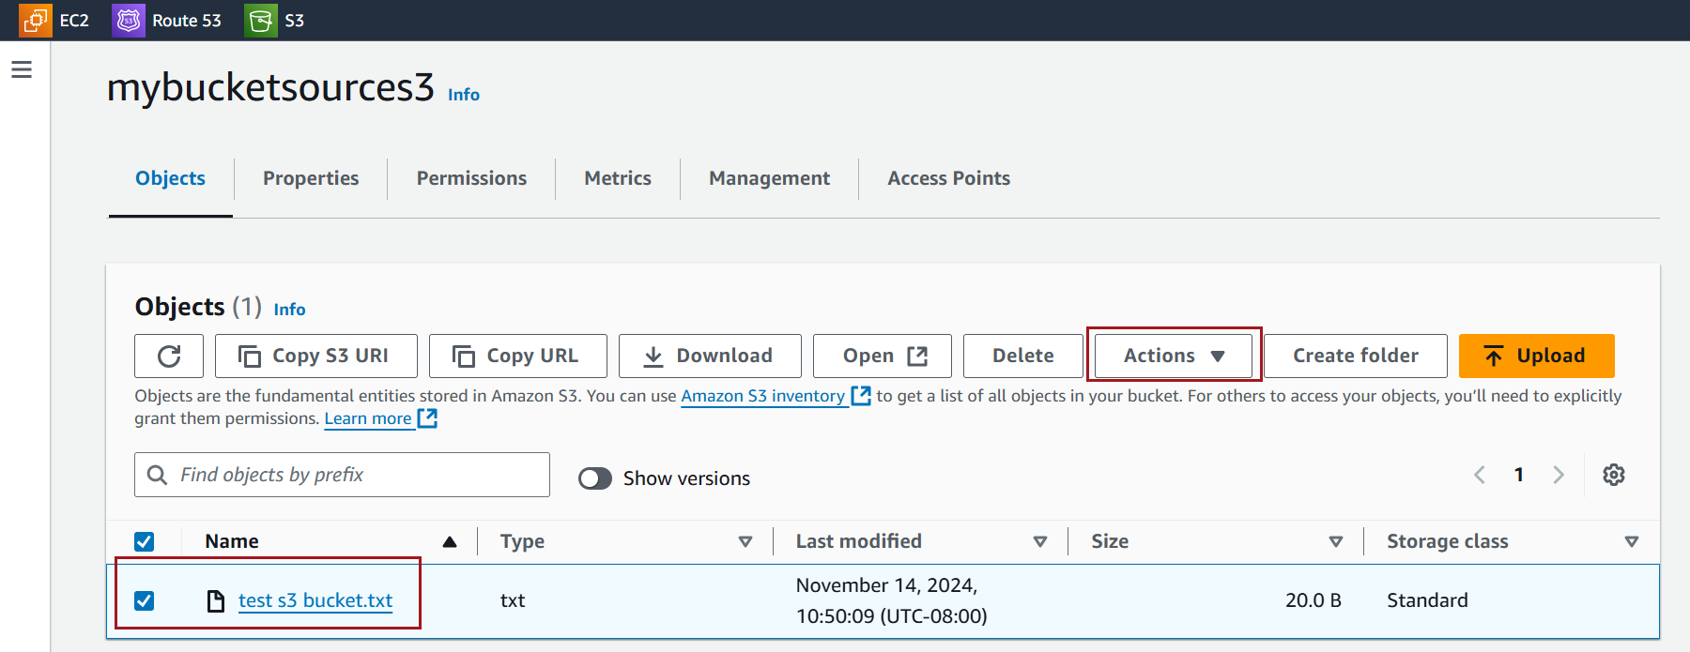

Click on Make public using ACL

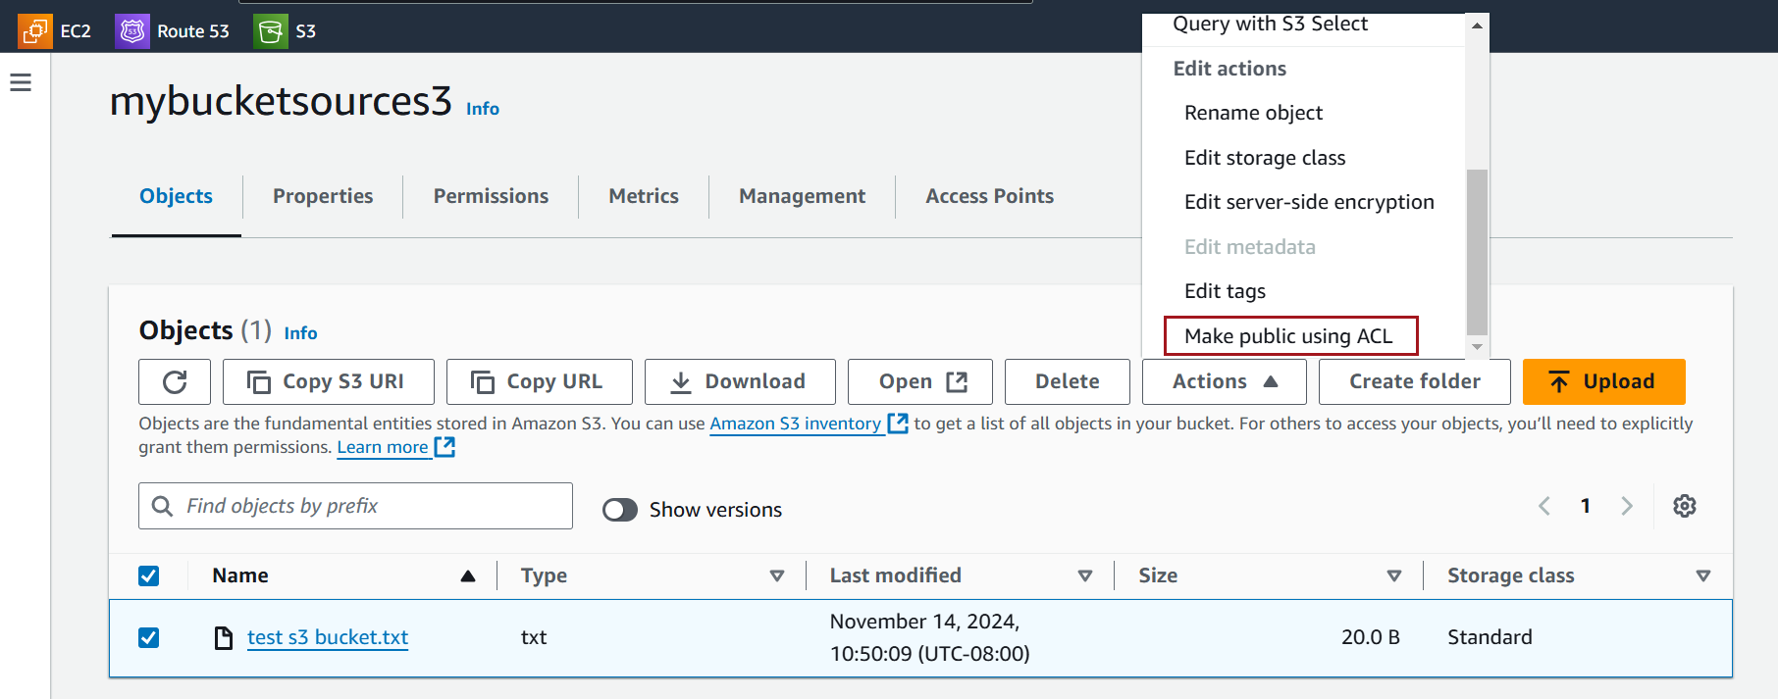

Click on Make public and then click on Close on the next screen

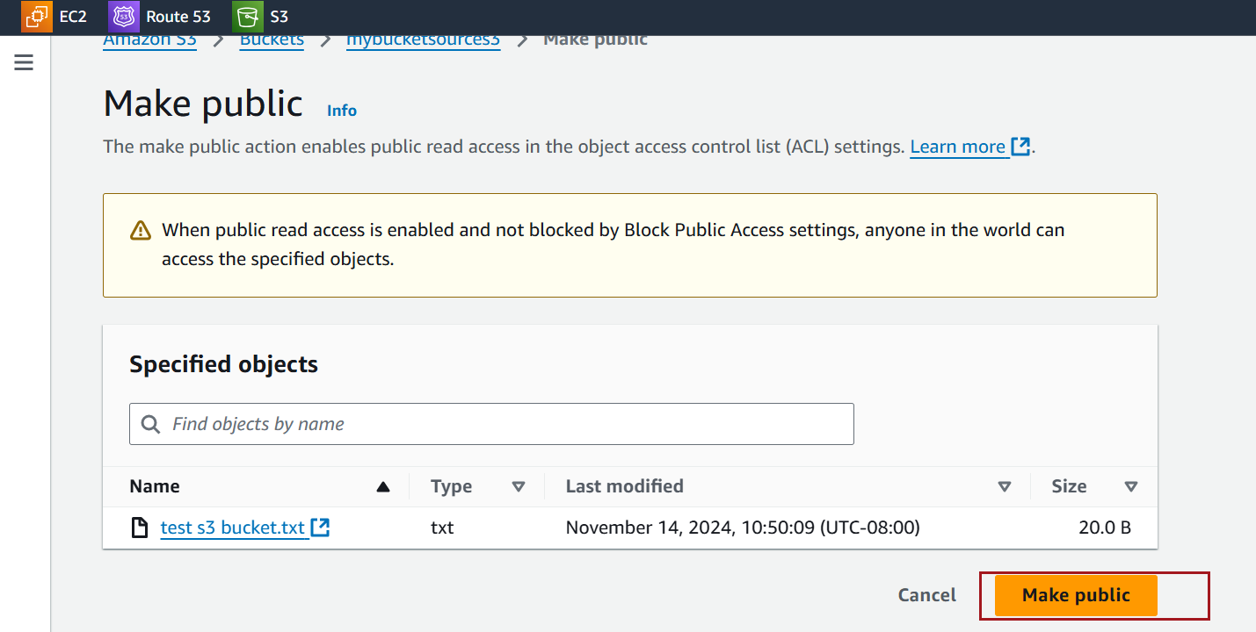

Verify Public Access

Once the ACL is set to public, Select your file or object

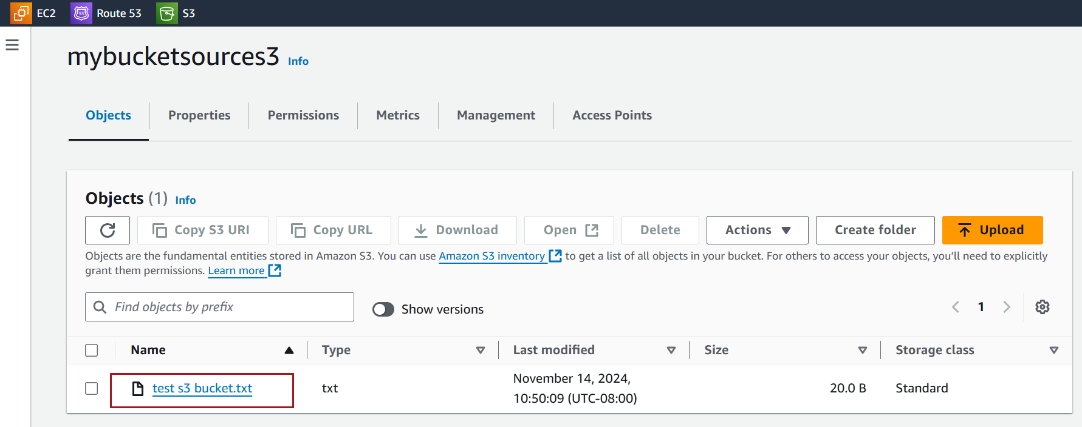

copy the **Object URL** from the object's overview

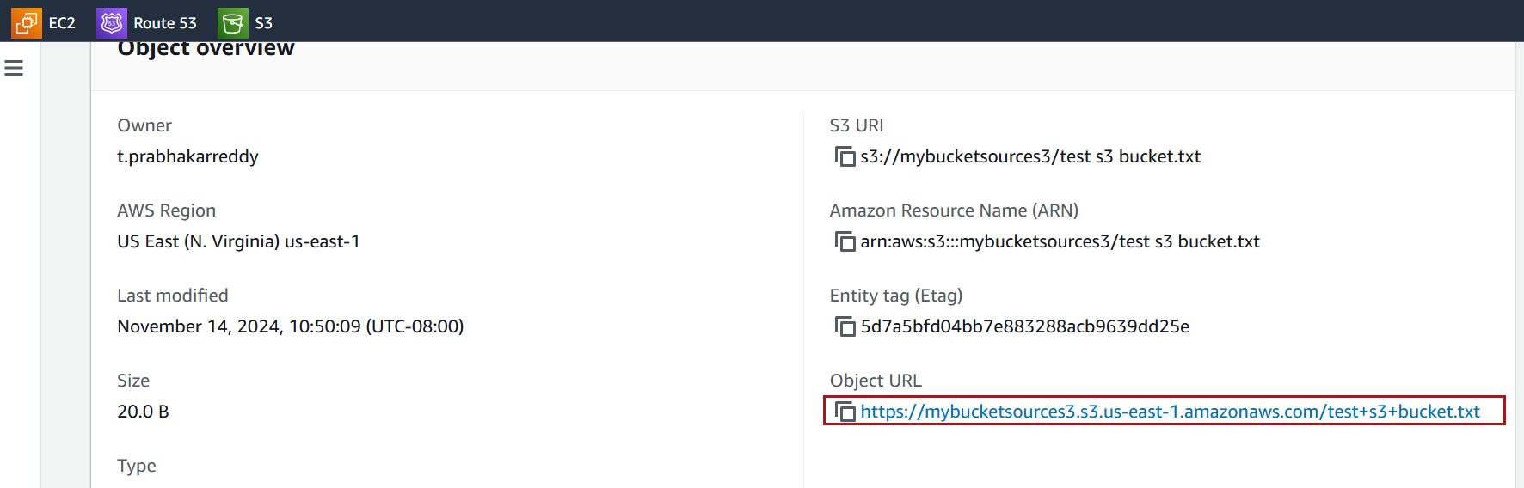

Paste the URL into a browser or another machine to ensure the object is accessible publicly

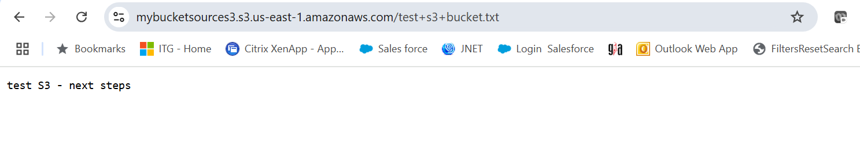

### **Screenshot for Changing the Storage class of objects**

Select the bucket that contains the objects you want to change

Go to the **Objects** tab, and navigate to the objects or folders whose storage class you want to change.

Check the boxes next to the specific objects you wish to modify. You can select multiple objects at once.

With the objects selected, click on the **Actions**

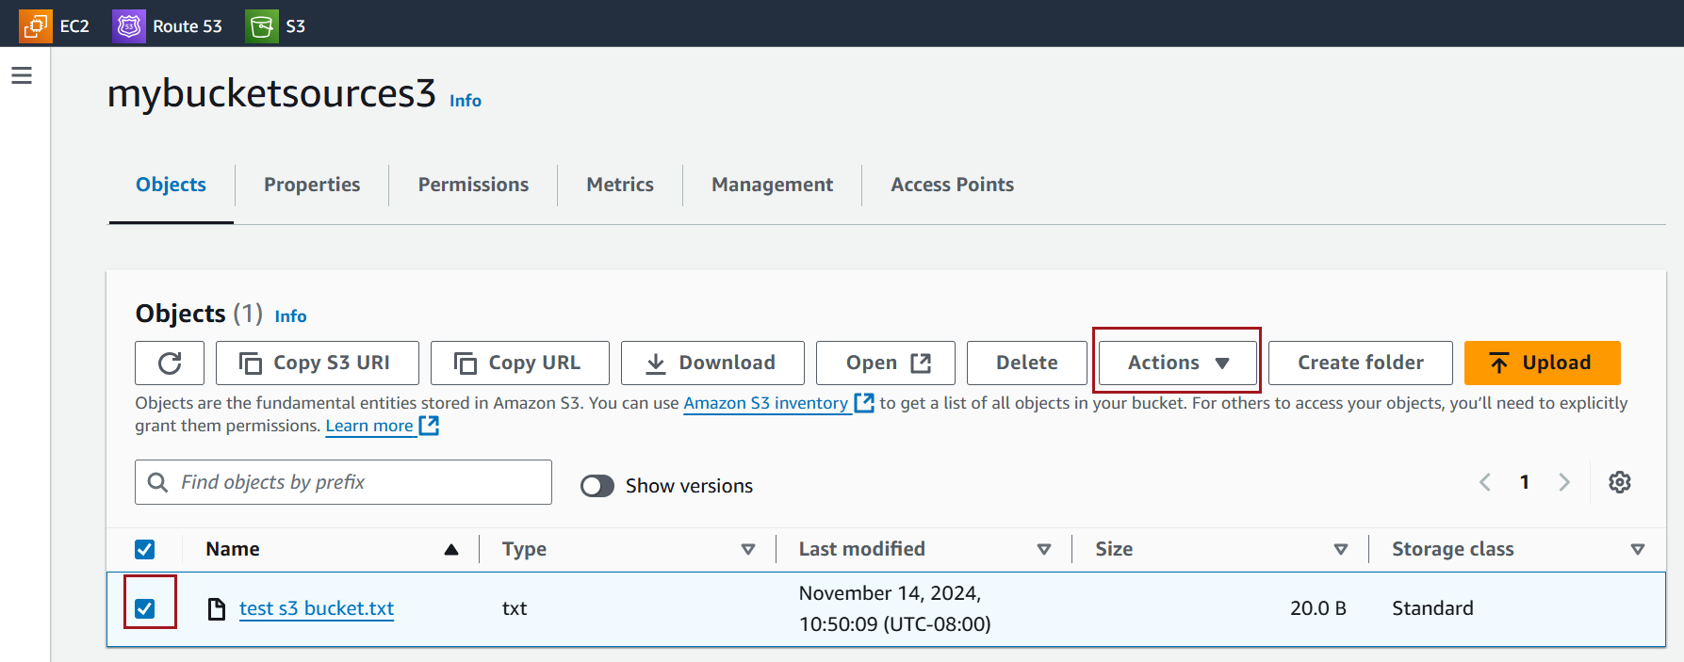

Choose **Edit storage class**

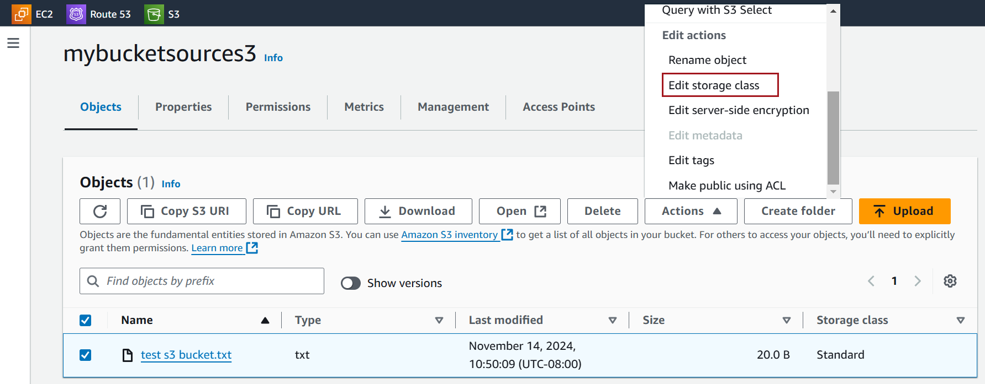

In the storage class options, select the desired storage class (e.g., Standard, Intelligent-Tiering, Standard-IA, Glacier, etc.).

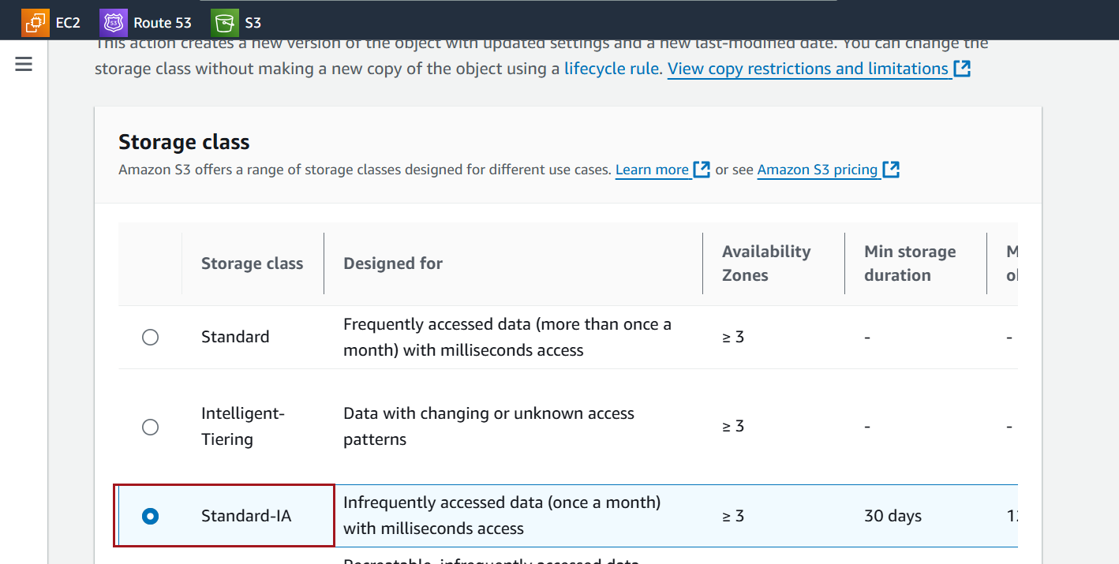

Click **Save changes**

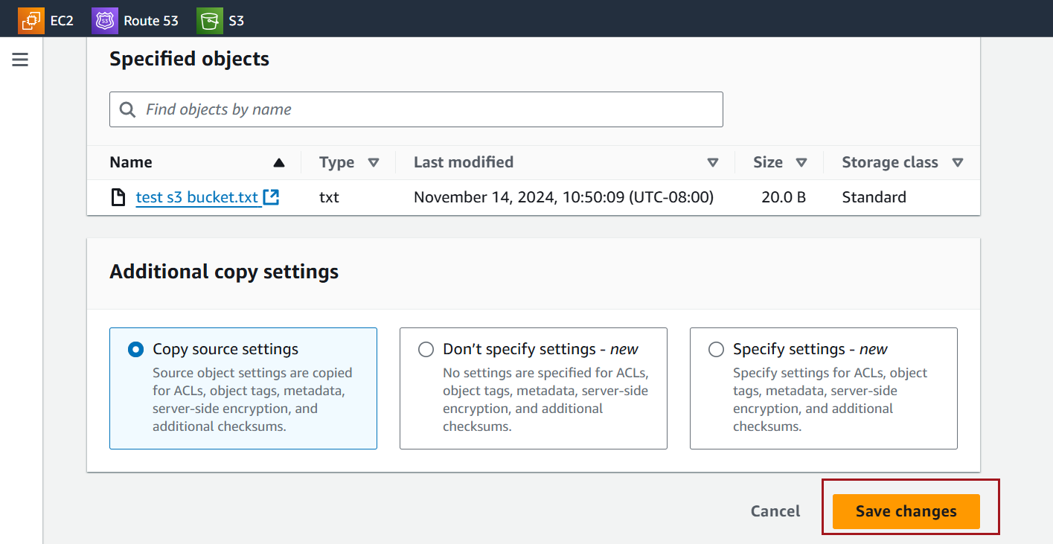

Observe that storage class is updated

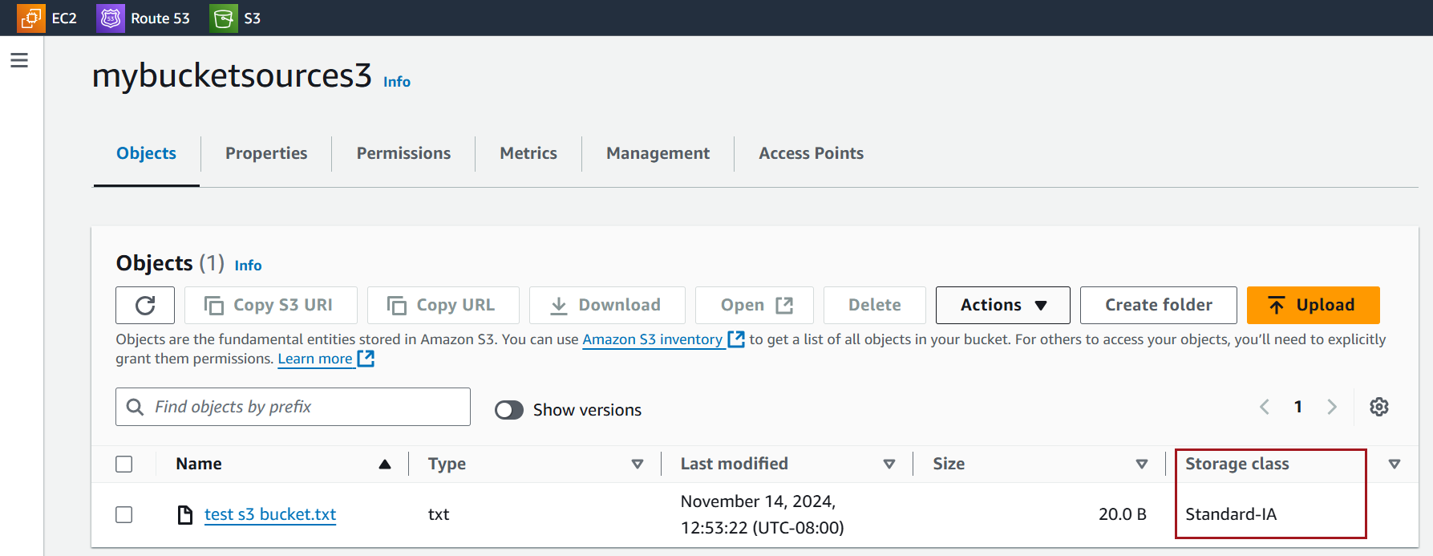

### **S3 Lifecycle Policies to Change Storage Classes**

Select the bucket where you want to change the storage class over time

Go to the **Management** tab

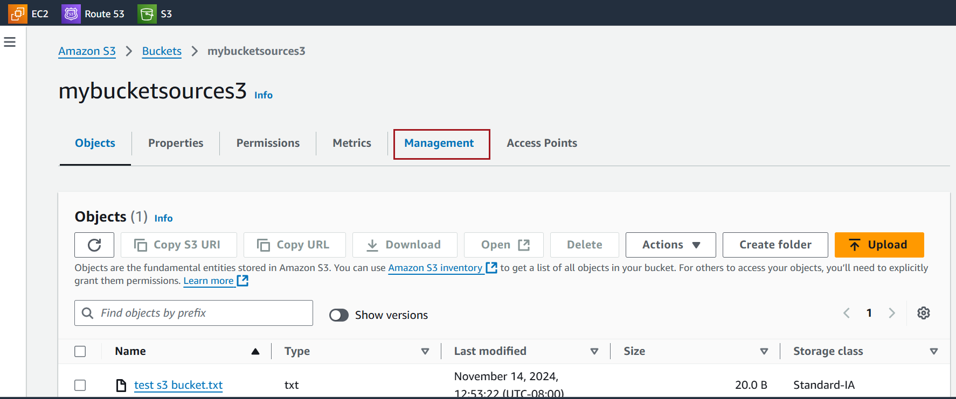

Select **Create lifecycle rule**.

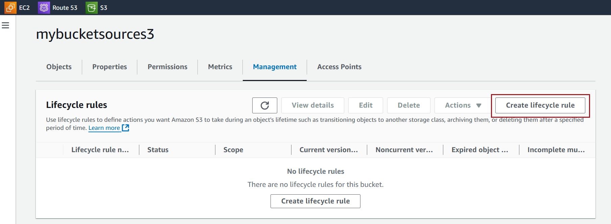

Name the rule and choose scope

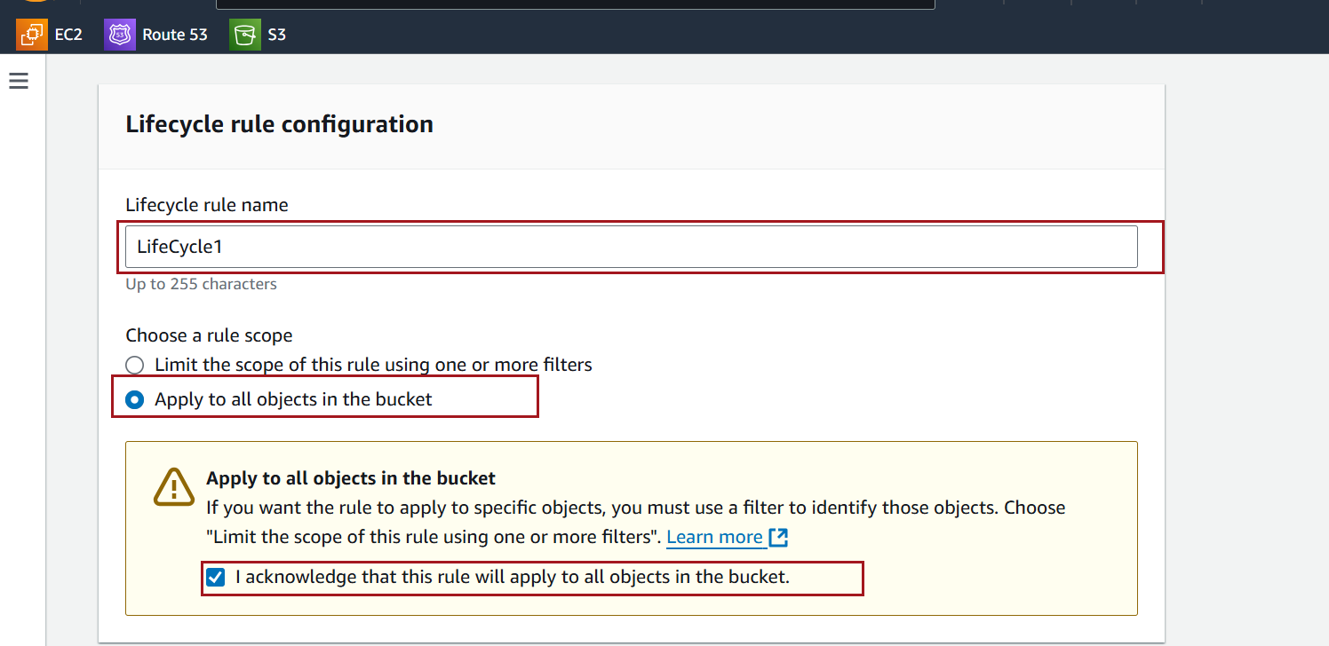

Select **Transition to a different storage class** and set conditions for when the objects should move to the new class

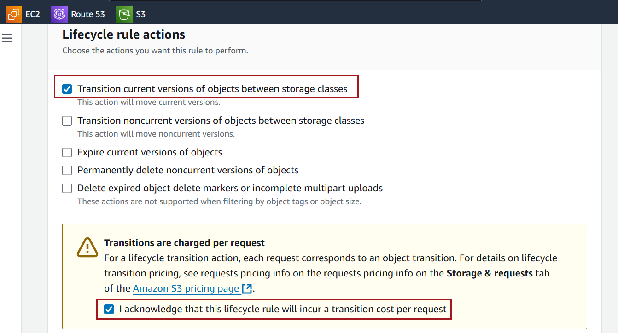

Choose the storage class you want the objects to transition to and specify the number of days after object creation for the transition.

Add additional transitions if needed

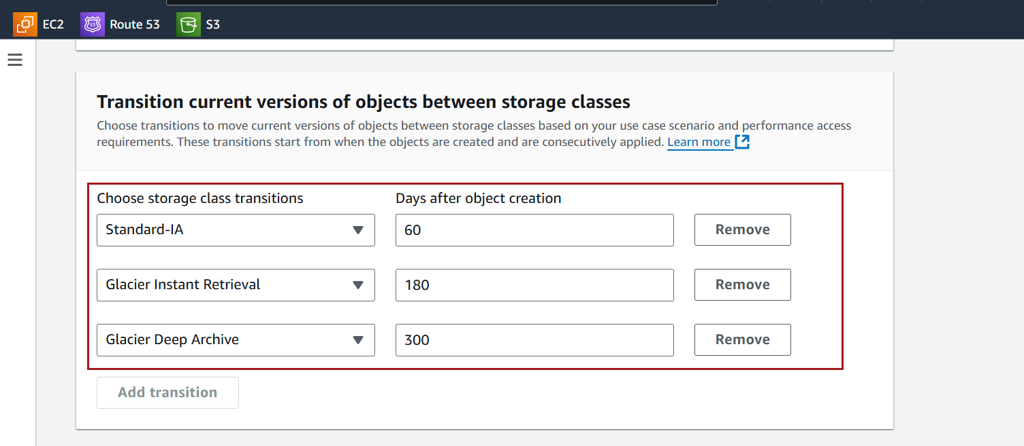

Click on Create rule

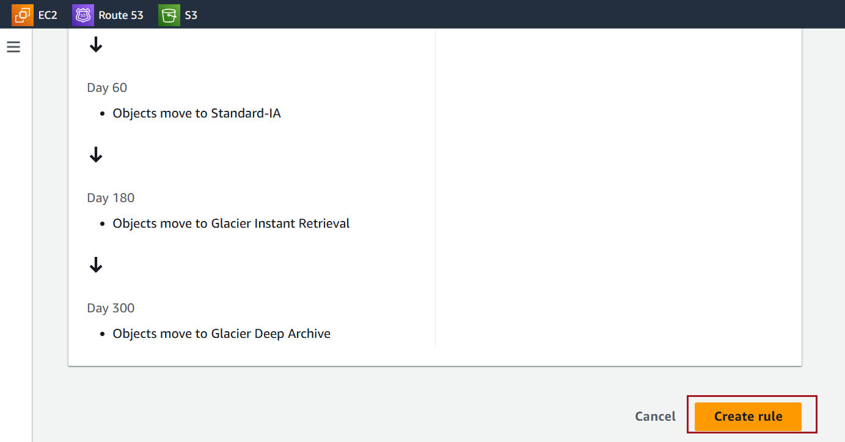

This will automatically move objects to the specified storage class based on the conditions you set.

### **Screenshot for Static Webhosting creation**

Click on the name of the bucket where you want to enable static hosting.

Make sure that bucket name is same as your domain name

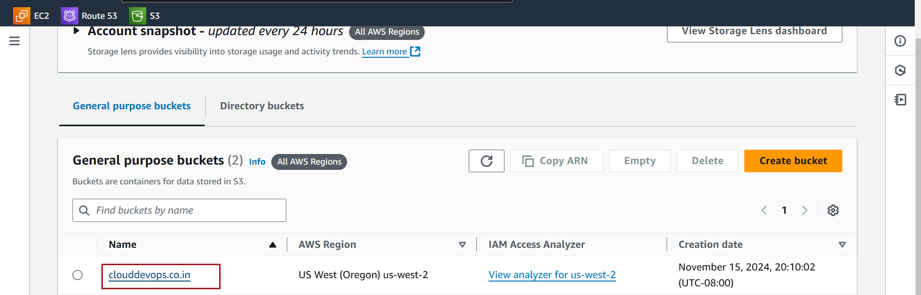

Click on the Permissions



At the top, you’ll see the **Block Public Access (Bucket Settings)** section.

Click **Edit** to adjust these settings



**uncheck** **Block all public access** Confirm by clicking **Save changes**.



To provide **read access** to a file in Amazon S3, it's also important to ensure that **Access Control Lists (ACLs)** are enabled.

Go to the **Permissions** tab of the bucket.



Click on **Object Ownership** setting.



Enable the ACLs



Acknowledge that ACLs will be restored and Click on save changes



Download the Website Template

Go to [Free CSS](https://www.free-css.com/).

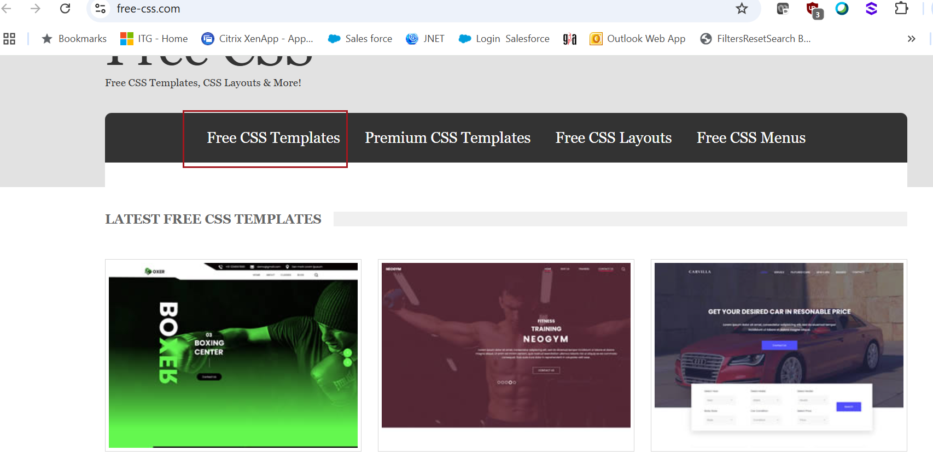

Browse through the free templates and select one.

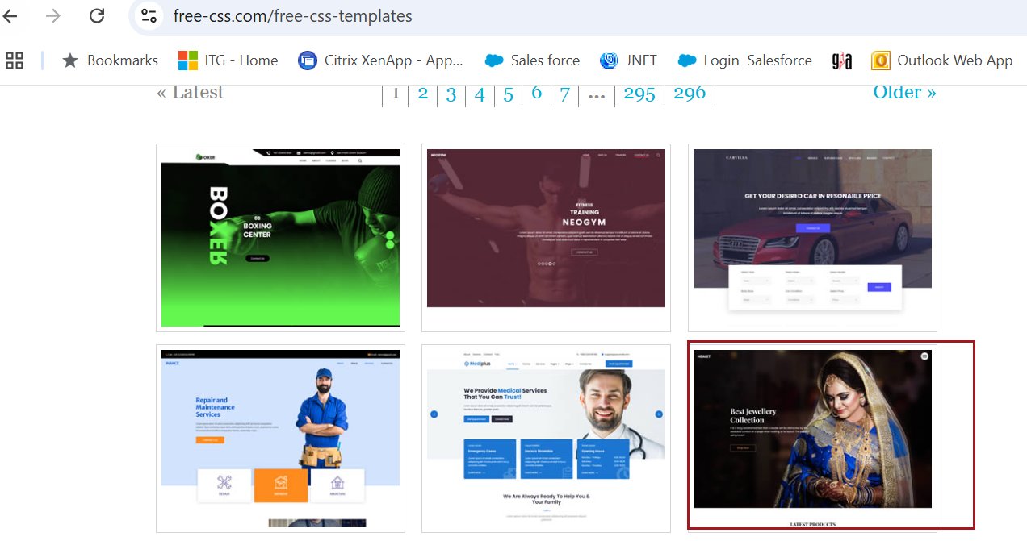

Click **Download** to save the .zip file containing the website template to your local machine.

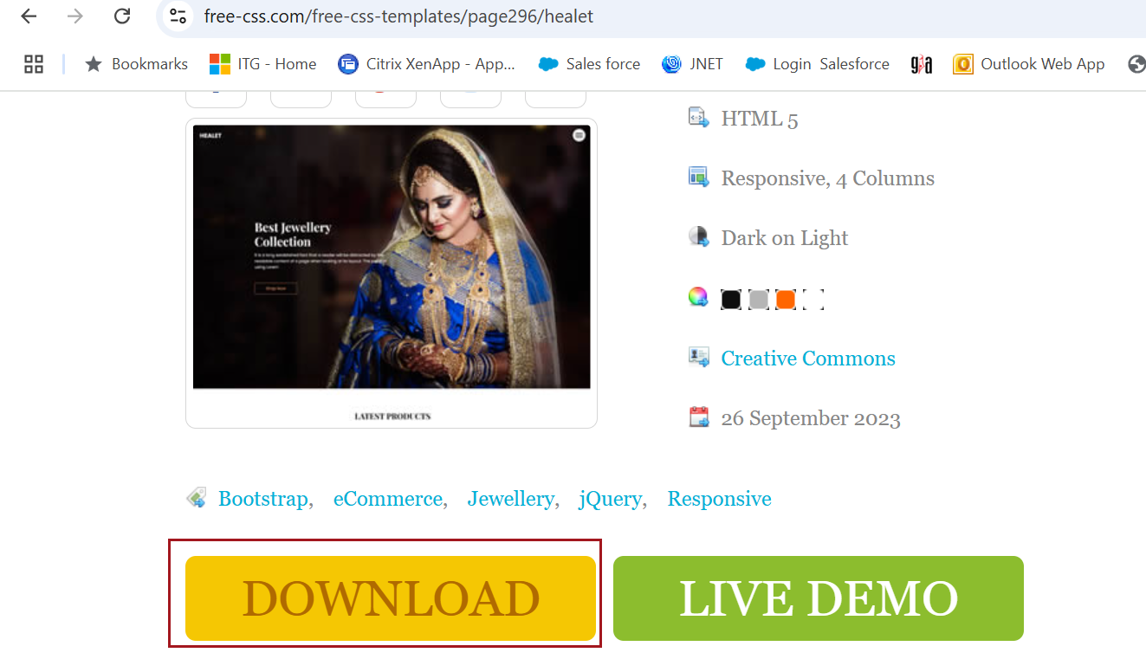

Locate the downloaded .zip file on your computer.

Extract the contents to a folder using tools like:

* Windows: Right-click → Extract All.

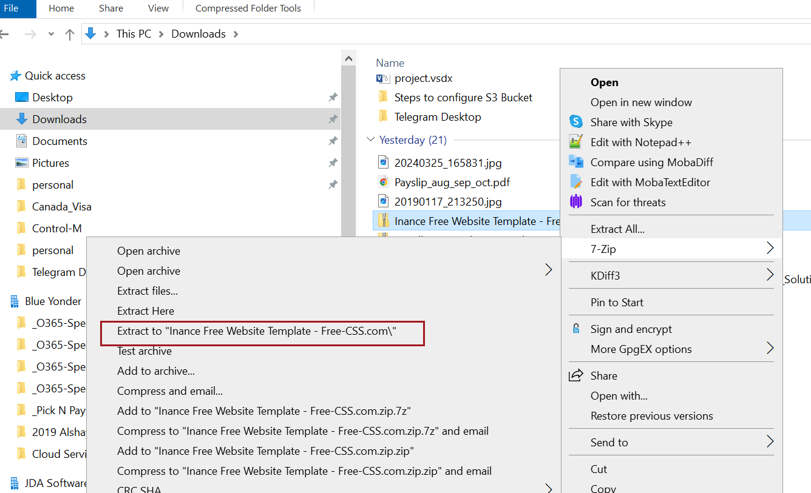

Copy Files to Your S3 Bucket

Go to the **Objects** tab and click **Upload**.

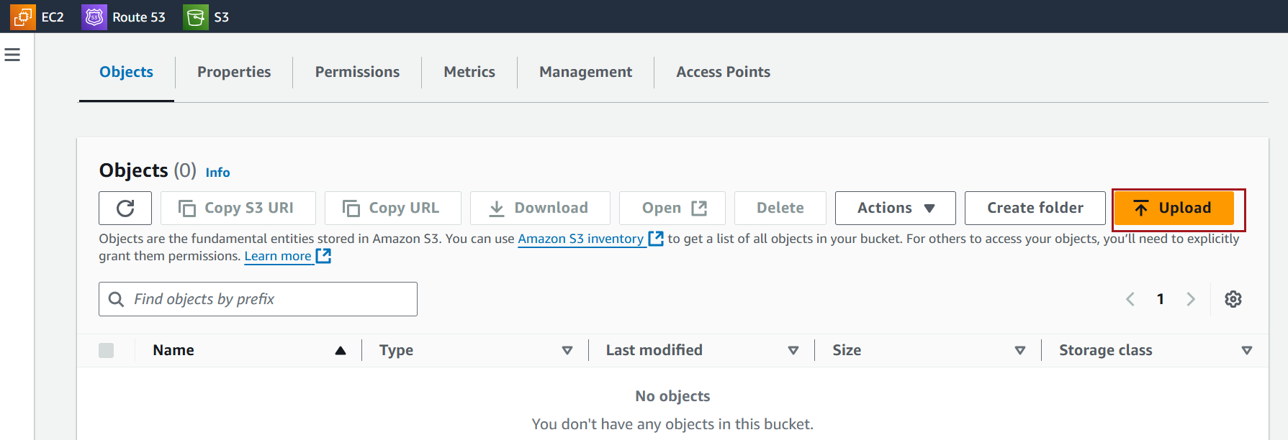

Add files and folders using the Add files and Add folder option

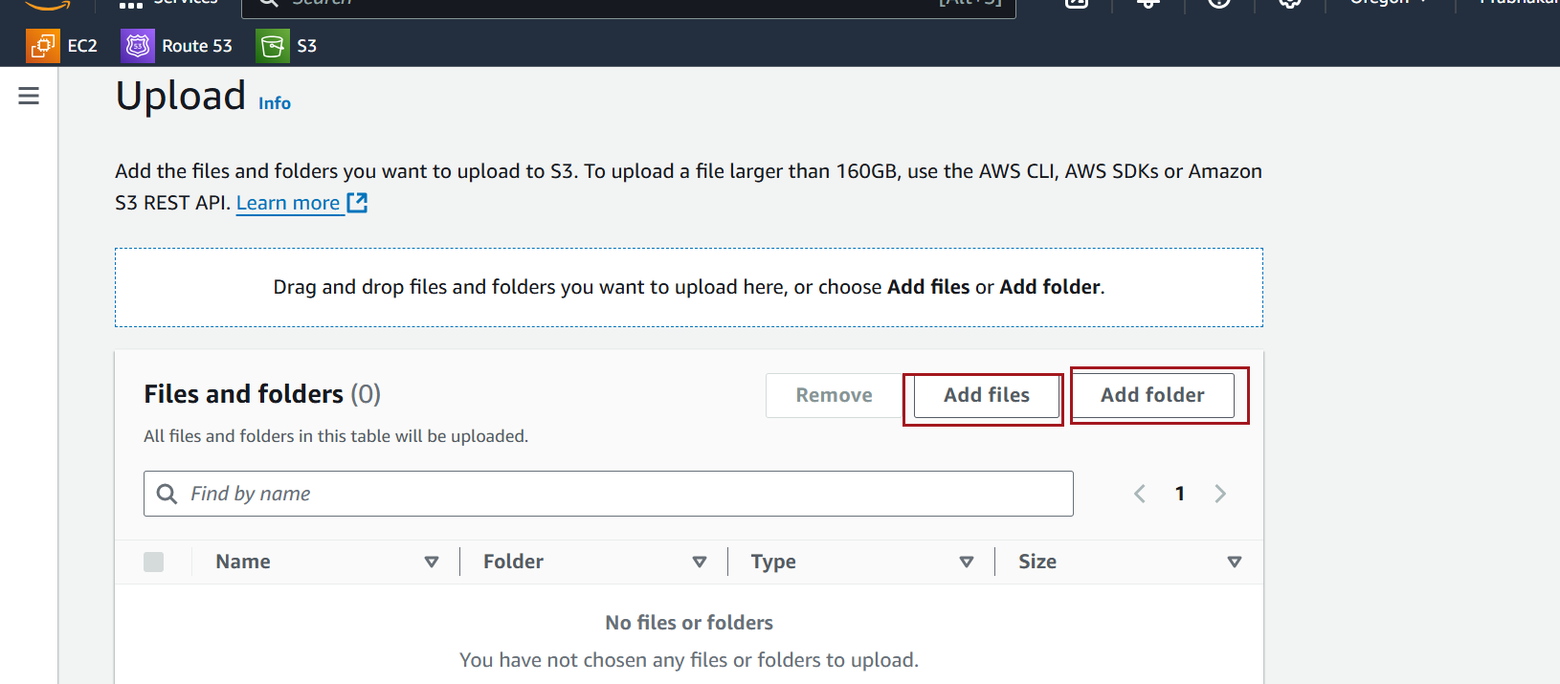

Click **Upload** to add the files to the bucket.

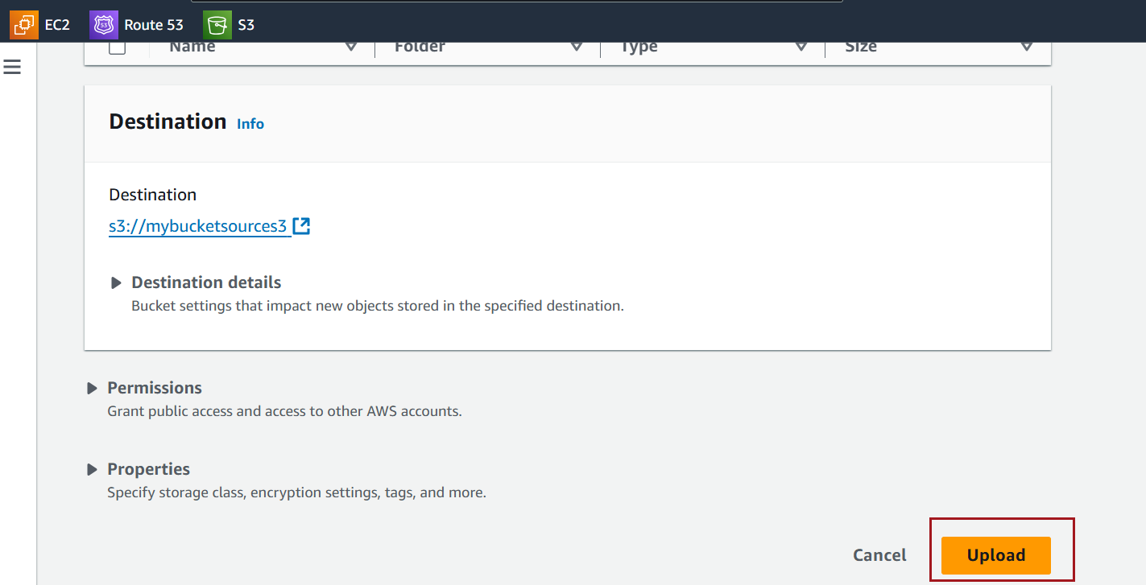

Select the files or folders to make public.

Click **Actions** → **Make public using ACL**.

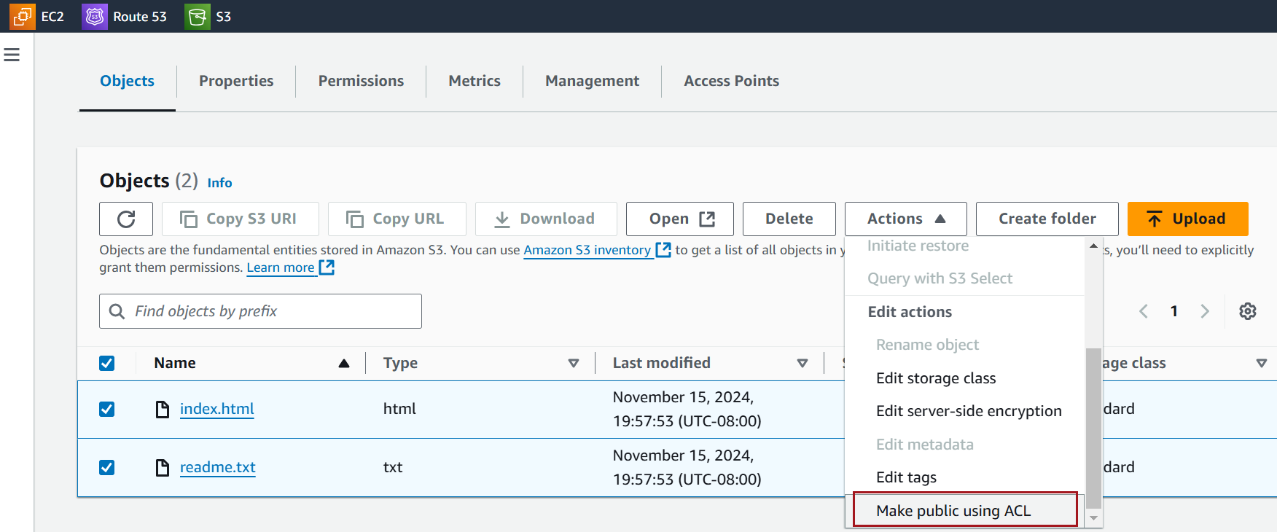

Click on make public

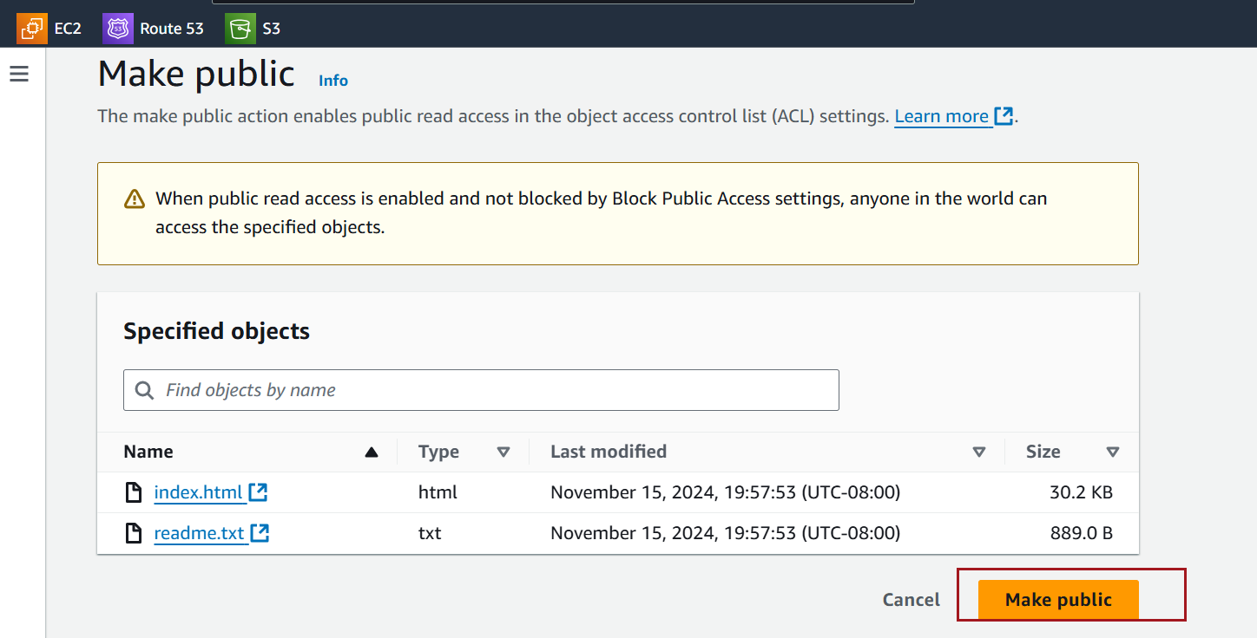

Enable Static Website Hosting

Navigate to the **Properties** tab of the bucket.

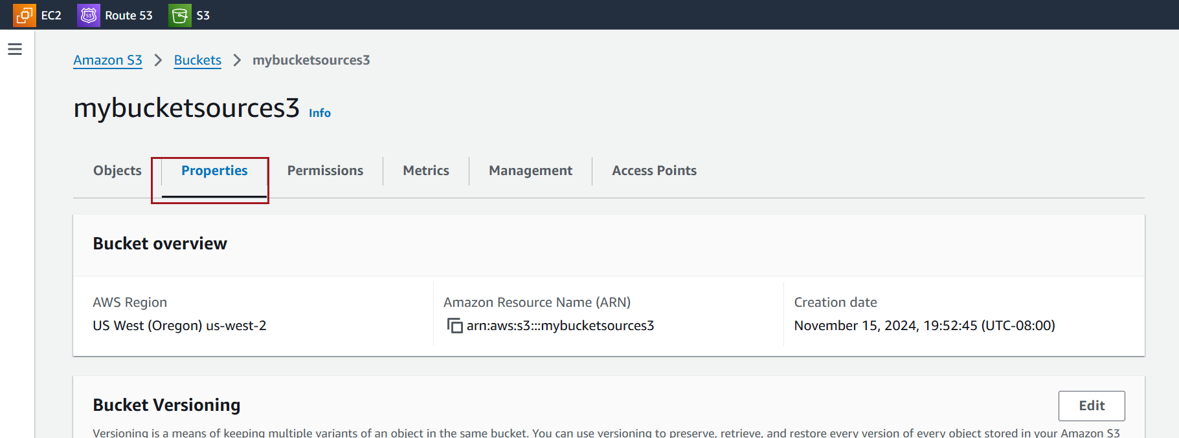

Scroll to **Static website hosting** and click **Edit**.

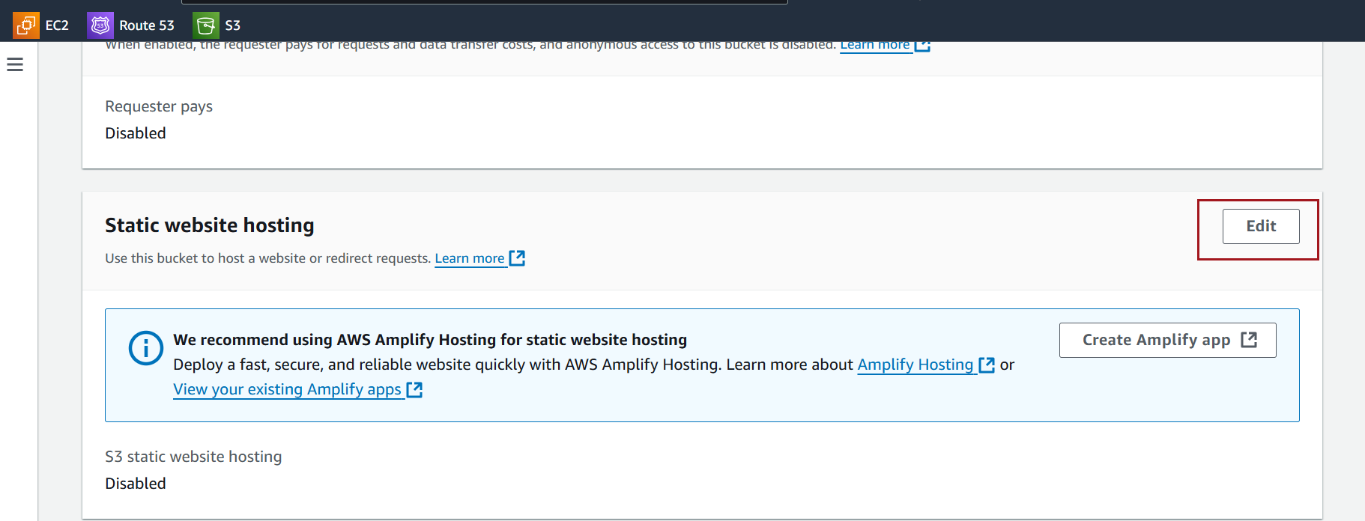

Enable static Website Hosting

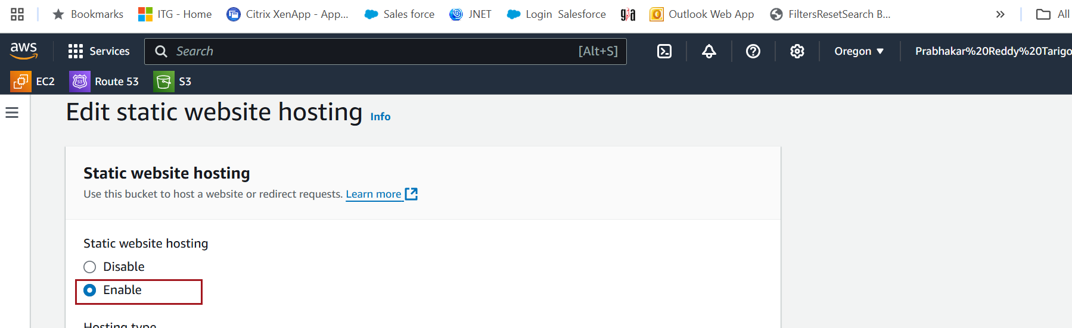

Enable it and configure:

* **Index document**: index.html.

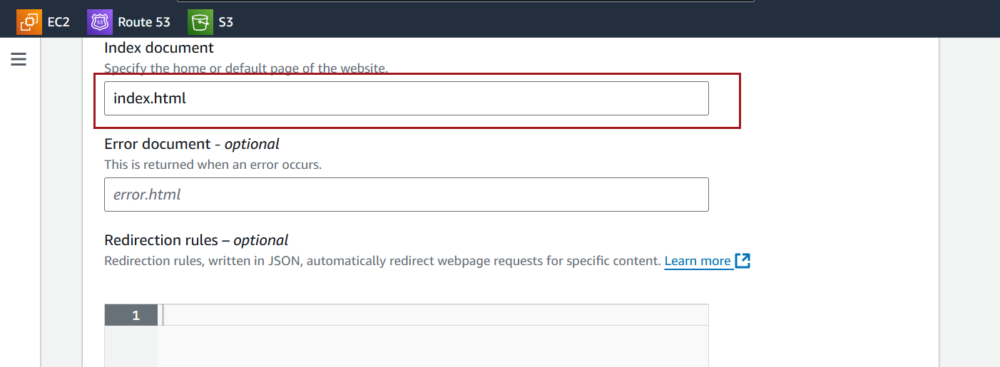

Save your changes.

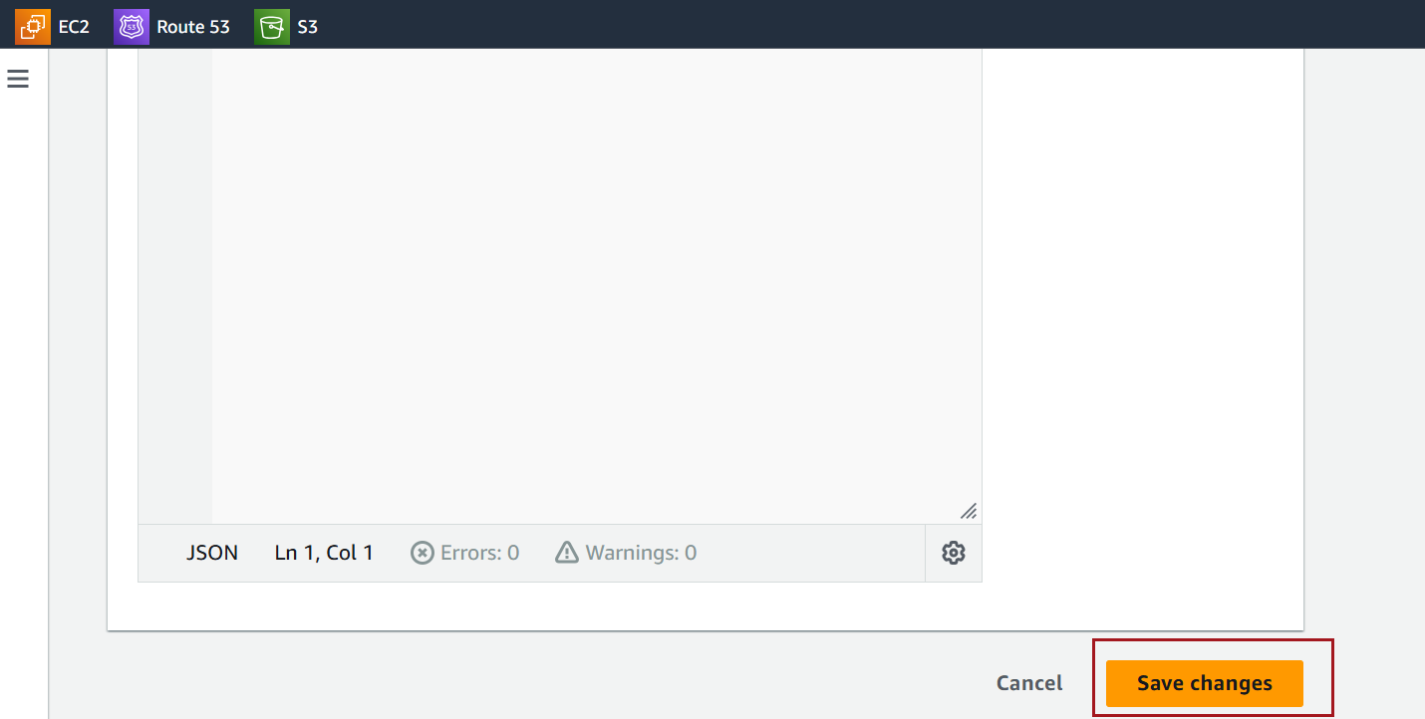

Add an Alias Record in Route 53

In the hosted zone for your domain, click **Create Record**.

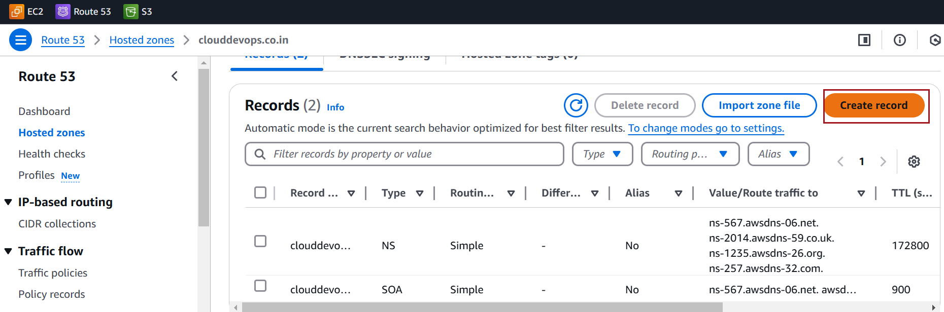

Configure the following:

* **Record Name**: Leave blank for the root domain or specify a subdomain (e.g., www).
* **Record Type**: A
* **Alias**: Enable **Alias**.
* **Route Traffic To**: Choose **Alias to S3 Website Endpoint**.
* Select the S3 bucket website endpoint from the list.

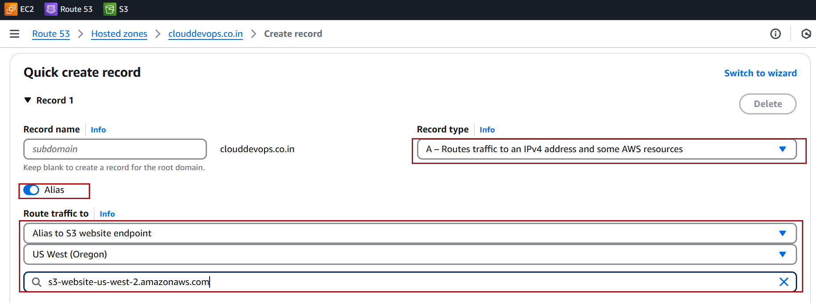

Click on Create record.

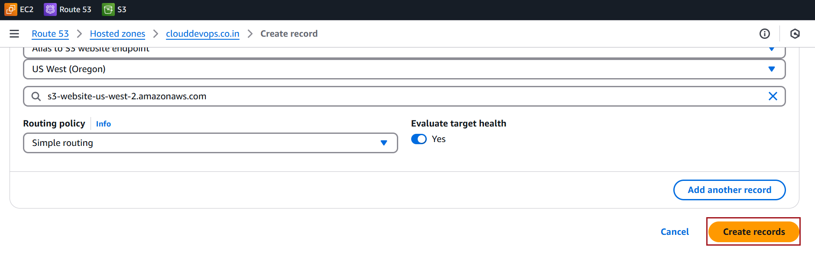

**Test Your Configuration**

1. Wait for DNS propagation (can take a few minutes to hours).
2. Visit your domain in a browser.